Customer Churn Prediction and Analysis



## Mini Project Report

## 21CSE315P-Data Orchestration and Management in Cloud Ecosystems

*Submitted by*

## Rachit Chandna [Reg. No: RA2311028010149]

## Hashmat Aziz Rather [Reg. No: RA2311028010178] *Under the Guidance of*

**Dr. S. Prabakeran**

Associate Professor, Department of Networking and Communications

*In partial fulfilment of the requirements for the degree of*

**BACHELOR OF TECHNOLOGY**

**in**

**COMPUTER SCIENCE AND ENGINEERING**

**with a specialization in Cloud Computing**

**DEPARTMENT OF NETWORKING AND COMMUNICATIONS SCHOOL OF COMPUTING**

**COLLEGE OF ENGINEERING AND TECHNOLOGY SRM INSTITUTE OF SCIENCE AND TECHNOLOGY**

**(Under Section 3 of UGC Act, 1956)**

SRM NAGAR, KATTANKULATHUR – 603 203 CHENGALPATTU DISTRICT

**NOVEMBER 2025**



SRM INSTITUTE OF SCIENCE AND TECHNOLOGY

KATTANKULATHUR - 603 203

BONAFIDE CERTIFICATE

Certified that this B.Tech, Minor project report titled “**Customer Churn Prediction and analysis**" is the bonafide work of **Rachit Chandna [RA2311028010149] and Hashmat Aziz[RA2311028010178]** who carried out the project work under my supervision. Certified further, that to the best of my knowledge the work reported herein does not form part of any other thesis or dissertation based on which a degree or award was conferred on an earlier occasion for this or any other candidate.

Dr. S. Prabakeran Dr. M. LAKSHMI

SUPERVISOR PROFESSOR AND HEAD

Associate Professor Department of Networking and

Department of Networking and Communications Communications,

SRM INSTITUTE OF SCIENCE AND SRM INSTITUTE OF SCIENCE AND TECHNOLOGY, KTR TECHNOLOGY, KTR



**Department of Networking and Communications SRM Institute of Science and Technology**

**Own Work Declaration Form**

Degree/ Course : B.Tech

### Student Name : Rachit Chandna , Hashmat Aziz Rather

Registration Number : RA2311028010149, RA2311028010178

**Title of Work : Customer Churn Prediction and Analysis**

I hereby certify that this assessment compiles with the University’s Rules and Regulations relating to Academic misconduct and plagiarism**, as listed in the University Website, Regulations, and the Education Committee guidelines.

I confirm that all the work contained in this assessment is my own except where indicated, and that I have met the following conditions:

* Clearly referenced / listed all sources as appropriate
* Referenced and put in inverted commas all quoted text (from books, web, etc.)
* Given the sources of all pictures, data etc. that are not my own
* Not made any use of the report(s) or essay(s) of any other student(s) either past or present
* Acknowledged in appropriate places any help that I have received from others (e.g. fellow students, technicians, statisticians, external sources)
* Compiled with any other plagiarism criteria specified in the Course handbook / University website

I understand that any false claim for this work will be penalized in accordance with the University policies and regulations.

I am aware of and understand the University’s policy on Academic misconduct and plagiarism and I certify that this assessment is my own work, except where indicated by referring, and that I have followed the good academic practices noted above.

**Rachit Chandna (RA2311028010149)**

**Hashmat Aziz Rather (RA2311028010178)**

**DECLARATION:**

# ACKNOWLEDGEMENT

We express our humble gratitude to **Dr. C. Muthamizhchelvan,** Vice-Chancellor, SRM Institute of Science and Technology, for the facilities extended for the project work and his continued support.

We extend our sincere thanks to Dean-CET, SRM Institute of Science and Technology, **Dr. Leenus Jesu Martin M ,** for his invaluable support.

We wish to thank **Dr. Revathi Venkataraman, Professor & Chairperson**, School of Computing, SRM Institute of Science and Technology, for her support throughout the project work.

We also wish to thank **Dr. M Pushpalatha, Associate Chairperson**, School of Computing, SRM Institute of Science and Technology, for her guidance throughout the project.

We are incredibly grateful to our Head of the Department, **Dr. M. Lakshmi**, Professor and Head, Department of Networking and Communications, School of Computing, SRM Institute of Science and Technology, for her suggestions and encouragement at all the stages of the project work.

Our inexpressible respect and thanks to our guide, **Dr. S. Prabakeran**, Associate Professor, Department of Networking and Communications, SRM Institute of Science and Technology, for providing us with an opportunity to pursue our project under his/her mentorship. He provided us with the freedom and support to explore the research topics of our interest. His passion for solving problems and making a difference in the world has always been inspiring.

We sincerely thank the Networking and Communications, Department staff and students, SRM Institute of Science and Technology, for their help during our project. Finally, we would like to thank parents, family members, and friends for their unconditional love, constant support, and encouragement.

Rachit Chandna[RA2311028010149] Hashmat Aziz Rather[RA2311028010178]

**CHAPTER NO TITLE PAGE NO**

**ABSTRACT** **7**

|  |  |  |  |  |
| --- | --- | --- | --- | --- |
|  | | | **LIST OF FIGURES** | **8** |
| **1.** |  |  | **INTRODUCTION** | **9-13** |
|  |  |  | 1.1 General | **9-10** |
|  |  |  | 1.2 Purpose | 10-11 |
|  |  |  | 1.3 Scope | 11 |
|  |  |  | 1.4 Problem Statement | 12 |
|  |  |  | 1.5 Objective Of the Project | 12-13 |
|  | **2.** |  | **LITERATURE REVIEW** | **14-22** |
|  |  |  | 2.1 Research Findings | 14-16 |
|  |  |  | 2.2 Current Approaches | 16-17 |
|  |  |  | 2.3 Limitations of Standalone Models | 17-18 |
|  |  |  | 2.4 Hybrid Approaches | 18-19 |
|  |  |  | 2.5 Traditional Methods | 19-20 |
|  |  |  | 2.6 Machine Learning-Based Approaches | 20-22 |
|  |  | **3.** | **SYSTEM ARCHITECTURE** | **23-28** |
|  |  |  | 3.1 System Architecture | 23-24 |
|  |  |  | 3.2 Architecture diagram | 24 |
|  |  | **4.** | **PROPOSED METHODOLOGY** | **29-35** |
|  |  |  | 4.1 Dataset Overview | 29 |
|  |  |  | 4.2 Schema Description | 29-30 |
|  |  |  | 4.3 Activity Diagram for proposed model | 31-32 |
|  |  |  | 4.4 Use Case Diagram for proposed model | 32-33 |

|  |  |
| --- | --- |
| **IMPLEMENTATION OF RFC** | **36-38** |
| 5.1 Dataset Description | 36 |
| 5.2 Data Collection and preprocessing | 37 |
| 5.3 Initial Model Training | 38 |
| **RESULT AND DISCUSSON** | **39-42** |
| 6.1 Dataset Description | 40 |
| 6.2 Dashboard | 41-42 |
| **CONCLUSION AND FUTURE SCOPE** | **43-44** |
| 7.1 Conclusion | 43 |
| 7.2 Future Expansion | 44 |
| **REFERENCES** | **45-47** |

# ABSTRACT

Customer churn — when customers discontinue a company’s product or service — directly affects profitability and long-term business growth. Accurately predicting potential churners allows organizations to design effective retention strategies and optimize marketing efforts. This project presents an end-to-end **Customer Churn Prediction System** built using **Machine Learning** techniques and integrated with **AWS Cloud services** for scalable storage, training, and deployment.

The system leverages a structured **telecom customer dataset** containing demographic, behavioral, and account-related attributes. Data preprocessing includes cleaning, encoding categorical variables, handling missing values, normalization, and balancing the dataset using **SMOTE (Synthetic Minority Oversampling Technique)**. The core predictive model employs the **Random Forest Classifier from Scikit-Learn (sklearn.ensemble)** due to its ability to handle large datasets with numerous features, efficiently process both categorical and numerical data, resist overfitting compared to single Decision Trees, and provide interpretable feature importance insights.

Model evaluation metrics such as **accuracy, precision, recall, F1-score, and ROC-AUC** confirm the high performance and generalization capability of the Random Forest model. AWS services are utilized to ensure scalability and reliability: **Amazon S3** for secure data storage, **AWS Cloud9** for model training and development, and **AWS Lambda** for serverless model deployment. The final application includes a **web interface** that allows users to input customer details and visualize churn probability and feature importance dynamically.

This project demonstrates how cloud-integrated machine learning solutions can empower organizations to make data-driven decisions, improve customer retention, and optimize resource allocation. Future work can focus on implementing **automated retraining pipelines, deep learning-based enhancements, and business intelligence integrations** to further enhance predictive accuracy and operational efficiency.

***Keywords:*** Customer Churn Prediction, Random Forest Classifier, Scikit-Learn, AWS Cloud, Cloud9, Amazon S3, AWS Lambda, SMOTE, Feature Engineering, Machine Learning, Predictive Analytics, Data Preprocessing, Model Evaluation, Flask Web Deployment, Scalable AI Systems.

**LIST OF FIGURES**

|  |  |  |
| --- | --- | --- |
| **Figure No** | **Figure Name** | **Page** |
| **3.2** | **Architecture Diagram** | **24** |
| **4.3** | **Activity Diagram** | **31** |
| **4.4** | **Use Case Diagram** | **32** |
| **4.5** | **Sequence Diagram** | **33** |
| **4.6** | **Class Diagram** | **34** |
| **6.1.1**  **6.1.2**  **6.1.3**  **6.1.4**  **6.1.5** | **Dashboard**  **Dashboard filters**  **Dashboard features**  **Customer Insights**  **Customer History** | **40**  **41**  **41**  **42**  **42** |

# CHAPTER 1

**INTRODUCTION TO CUSTOMER CHURN PREDICTION USING MACHINE LEARNING AND AWS CLOUD INTEGRATION**

In recent years, predicting customer churn has become one of the most crucial aspects of modern business intelligence and data analytics. Organizations across industries — telecom, banking, retail, and e-commerce — depend heavily on data-driven insights to retain existing customers, as acquiring new ones is significantly more expensive. The growing availability of large-scale customer data and advancements in machine learning (ML) have enabled companies to predict which customers are likely to discontinue their services. This project leverages **machine learning algorithms** and **AWS Cloud integration** to develop a scalable churn prediction system that helps businesses identify potential churners early and take proactive measures.

Customer churn prediction involves analyzing customer behavior, usage history, demographics, and feedback data to estimate the likelihood of churn. The model’s predictive capability assists organizations in designing retention strategies such as personalized offers, loyalty programs, or targeted marketing campaigns. This project integrates **AWS services such as S3, Cloud9, and Lambda** to ensure secure data storage, cloud-based model training, and efficient web-based deployment. By automating the end-to-end pipeline, the proposed system demonstrates how predictive analytics and cloud computing together enhance operational efficiency and customer relationship management.

## General

Customer churn refers to the rate at which customers stop doing business with a company within a given period. It is a key indicator of customer dissatisfaction, poor service quality, or competitive pressure. In telecom, for example, churn occurs when subscribers switch to another provider, while in banking, it happens when clients close their accounts. The challenge for businesses is not only to identify which customers are leaving but also to understand why.

Machine learning offers an advanced solution by analyzing large datasets to uncover hidden patterns that correlate with churn behavior. Models such as **Random Forest**, **Logistic Regression**, and **XGBoost** have proven effective in predicting churn with high accuracy. These algorithms can handle complex relationships between categorical and numerical features, delivering interpretable insights like feature importance — which helps companies understand the primary drivers of customer attrition.

With the rise of digitalization, organizations generate massive volumes of customer data every second through mobile usage, transactions, and feedback channels. This enormous data stream is often described by the three V’s of big data — **Volume**, **Variety**, and **Velocity**. Managing such large-scale data efficiently requires cloud platforms like **Amazon Web Services (AWS)** that offer scalable infrastructure and advanced data engineering tools.

AWS provides services such as **Amazon S3** for data storage, **AWS Cloud9** for model development, and **AWS Lambda** for deploying predictive models in a serverless architecture. These tools enable real-time data processing, secure access, and seamless integration between front-end applications and back-end models.

The synergy of **Machine Learning** and **Cloud Computing** thus provides a powerful framework for predictive analytics. It allows businesses to not only predict customer churn with high precision but also deploy models that scale automatically as data volume increases. This integration bridges the gap between analytics and action — transforming raw data into intelligent decisions that directly improve customer retention and profitability.

## Purpose

Customer churn prediction based on behavioral and transactional data is a highly influential analytical tool because it enables businesses to understand customer dissatisfaction and anticipate future attrition trends. The project aims to utilize a structured customer dataset containing demographic details, usage statistics, service feedback, and account information to predict which customers are likely to discontinue their service or subscription with a company.

The process begins by collecting and consolidating customer-related data from multiple sources such as CRM systems, transaction logs, and web forms. The collected dataset is then stored securely in **Amazon S3**, where it undergoes extensive preprocessing to eliminate missing values, duplicates, and inconsistencies. This also includes normalization, label encoding for categorical attributes, and data balancing using **SMOTE** to ensure fair representation of churned and retained customers. These preprocessing steps enhance the accuracy and reliability of the prediction process.

The next stage involves the application of **Machine Learning techniques** to implement the predictive model. The **Random Forest Classifier from Scikit-Learn** is employed because of its ability to manage large datasets with many input features, work effectively with both categorical and numerical data, and provide interpretable outputs through feature importance rankings. The trained model classifies customers into two primary categories — churned and retained — based on their behavioral and demographic attributes.

The model is developed and trained within **AWS Cloud9**, taking advantage of the cloud’s scalable computing power. Once trained, it is deployed using **AWS Lambda** through an API interface that enables real-time predictions. A **web dashboard** built with Flask allows analysts and business managers to input customer details, view churn probability scores, and interpret visual analytics like feature importance and confusion matrices. This ensures that decision-makers gain meaningful insights for developing personalized retention campaigns and improving customer engagement strategies.

## Scope

The scope of this project lies within the application of machine learning and cloud-based technologies for analyzing customer behavior data to predict churn probability in subscription-driven businesses. The main objective is to develop an automated and intelligent predictive model that identifies customers likely to discontinue their association with a company, thereby allowing businesses to take proactive measures to retain them. The system integrates data engineering, model development, evaluation, and deployment processes into a unified AWS-based architecture for end-to-end automation

To begin with, customer data — including demographic details, tenure, service usage patterns, payment history, and feedback ratings — is collected and stored securely on **Amazon S3**. The dataset is then filtered for relevance and completeness to ensure that only meaningful attributes contribute to model performance. The preprocessing phase includes steps such as missing value treatment, normalization, encoding of categorical variables, and balancing the dataset using **SMOTE (Synthetic Minority Oversampling Technique)** to avoid bias between churned and retained classes.

Following preprocessing, the **Random Forest Classifier** from **Scikit-Learn** is employed as the core predictive model. It is chosen for its robustness in handling large datasets with mixed data types, its resistance to overfitting, and its capability to generate feature importance rankings that help interpret model behavior. The trained model classifies customers into two categories: Churned and Retained, based on their behavioral and transactional features. Model performance is assessed through evaluation metrics such as **Accuracy, Precision, Recall, F1-Score, and ROC-AUC** to ensure predictive reliability.

Deployment of the trained model is achieved through **AWS Lambda** for serverless execution, while a **Flask-based web interface** serves as the front-end for user interaction. Business analysts and managers can input customer details into the web form and instantly receive churn prediction results, supported by graphical visualizations of model confidence and feature contributions.

In conclusion, the scope of this project extends to demonstrating how **machine learning integrated with AWS cloud services** can enable scalable, real-time churn prediction. It also contributes to ongoing research in intelligent business analytics by showcasing the effectiveness of cloud-based predictive systems in improving customer retention, profitability, and operational decision-making.

## Problem Statement

Customer retention has become one of the most significant challenges faced by modern organizations due to increasing competition, dynamic market behavior, and changing customer expectations. Conventional churn prediction methods generally rely on manual analysis or statistical models based on historical records; however, these models often fail to capture the complex behavioral patterns and real-time interactions that influence customer decisions. As businesses continue to collect vast amounts of customer data across multiple platforms — billing systems, feedback channels, and service usage logs — the challenge lies in extracting actionable insights efficiently and accurately.

Traditional analytical methods are limited by their inability to handle large, heterogeneous datasets and to generalize across varying customer segments. They also lack the adaptability required to update in real time as customer behavior changes. Consequently, many organizations face delayed or inaccurate churn detection, resulting in lost customers and decreased profitability.

To bridge this gap, this project focuses on applying **Machine Learning (ML)** techniques integrated with **AWS Cloud infrastructure** to automate and enhance the churn prediction process. The key challenge lies in efficiently preprocessing large volumes of structured and semi-structured customer data, training a reliable ML model, and deploying it in a scalable and accessible environment. The system must be capable of handling multiple data types, ensuring data integrity, and generating predictions that can directly inform retention strategies.

The central research problem is to determine whether the integration of **Random Forest-based predictive modeling** with **cloud-based deployment** can provide a scalable, accurate, and real-time solution for identifying customers likely to churn. The project ultimately seeks to transform traditional retention analysis into an automated, data-driven framework that enables organizations to make timely, informed decisions and strengthen customer loyalty.

## Objectives of the Project

The main purpose of this project is to analyze the potential of using machine learning algorithms for predicting customer churn and to build an intelligent, cloud-integrated system that helps businesses identify customers likely to discontinue their service. The project aims to develop a reliable **Random Forest-based predictive model** that can provide actionable insights to assist organizations in designing data-driven customer retention strategies. It explores how predictive analytics combined with **AWS Cloud services** can help automate data handling, model deployment, and real-time churn risk assessment for large-scale customer datasets.

**Data Collection**: The first objective involves gathering and organizing relevant customer data from reliable sources such as telecom databases, customer relationship management (CRM) systems, or publicly available churn datasets. The dataset includes diverse features such as customer ID, gender, age, tenure, payment methods, service usage patterns, total charges, and feedback ratings. The collected data is stored in **Amazon S3**, ensuring scalability, security, and easy access for subsequent processing. A sufficient volume of data is maintained to ensure diversity across customers, enabling accurate and generalizable model predictions.

**Data Preprocessing and Feature Engineering** Once the dataset is collected, preprocessing is performed to ensure data consistency and quality. This involves cleaning the data by handling missing values, removing duplicates, encoding categorical variables, and applying normalization or scaling where required. The **SMOTE (Synthetic Minority Oversampling Technique)** method is used to address class imbalance, ensuring equal representation of churned and retained customers. Additionally, feature selection techniques are employed to identify the most significant factors influencing customer churn, such as contract type, tenure, and service usage.

**Model Development and Training** The core objective of the project is to train a **Random Forest Classifier** using the **Scikit-Learn (sklearn.ensemble)** library. The Random Forest model is chosen due to its ability to handle large datasets with mixed data types, resist overfitting, and provide interpretable results through feature importance analysis. The model is trained within **AWS Cloud9**, which offers a robust cloud-based development environment. The trained model classifies customers into two categories — Churned or Retained — based on their input features, providing a probabilistic churn score that reflects the likelihood of customer departure.

**Integration and Cloud Deployment** Another key objective is to deploy the trained machine learning model using **AWS Lambda** to enable real-time prediction and automation. The system is integrated with a **Flask-based web application** that allows users to input customer details and instantly view churn prediction results along with feature importance graphs. The web interface is supported by AWS APIs that facilitate seamless communication between the front-end and the cloud-based prediction model, ensuring scalability and high availability.

**Evaluation and Insights Generation** Finally, the model is evaluated using key performance metrics such as **Accuracy, Precision, Recall, F1-Score, and ROC-AUC**, which collectively determine its reliability and robustness. Visualization tools and charts are used to represent model performance, feature contributions, and churn probabilities in an interpretable format. The final goal is to provide decision-makers with meaningful insights that can guide personalized retention campaigns, improve customer satisfaction, and enhance organizational profitability.

# CHAPTER2 LITERATURE SURVEY

## Research Findings

[1] **S. Ramaswamy, P. Bhatnagar, and M. Jain, “Customer Retention through Predictive Analytics using Random Forest Classifier,” IEEE Access, 2023:** This research explores how predictive analytics can be effectively used to improve customer retention rates by identifying potential churners through machine learning models. The study emphasizes the use of the **Random Forest Classifier** due to its robustness, interpretability, and ability to handle mixed data types. The authors utilized a large customer dataset from a telecom company and applied preprocessing techniques such as encoding, normalization, and feature scaling. Results showed that Random Forest outperformed traditional models like Logistic Regression and Decision Trees, achieving an accuracy of **91.8%**, with significant insight into key churn drivers such as contract duration, monthly charges, and payment methods. This study validates the use of ensemble learning methods in churn prediction and supports the integration of model interpretability in decision-making.

[2] **A. Mehta and R. Patel, “Machine Learning Approaches for Customer Churn Prediction: A Cloud-based Framework,” Journal of Cloud Computing, 2022:** The study presents a cloud-based machine learning framework for churn prediction in the telecommunication industry. Using **AWS Cloud** for storage and deployment, the authors demonstrated how cloud computing enhances scalability, performance, and cost efficiency for real-time analytics. Data preprocessing was performed using Amazon S3 and AWS Glue, while model training was executed on AWS SageMaker. Among the models tested—Random Forest, Gradient Boosting, and XGBoost—the Random Forest algorithm achieved the highest F1-score. The integration of cloud services improved model accessibility and reduced operational costs. The paper highlights that cloud-enabled machine learning workflows significantly streamline deployment and maintenance for business-scale predictive systems.

[3] **K. Srivastava, D. Sharma, and S. Khanna, “Analyzing Customer Churn using Random Forest and Logistic Regression Models,” International Journal of Data Analytics, 2021:** This research compares Random Forest and Logistic Regression models for predicting customer churn using a real-world telecom dataset. The dataset was preprocessed to remove inconsistencies, balance class distribution, and encode categorical variables. The authors observed that Random Forest performed better due to its ensemble nature and resistance to overfitting, producing an accuracy of **89%** compared to **82%** for Logistic Regression. Moreover, feature importance analysis helped identify major churn predictors such as contract type, tenure, and total charges. The study concludes that Random Forest provides both accuracy and interpretability, making it suitable for business decision-making environments.

[4] **M. Gupta and T. Roy, “Cloud-Based Machine Learning Pipeline for Customer Behavior Prediction,” Proceedings of the IEEE Cloud Summit, 2024:** This paper presents an integrated pipeline for predicting customer churn using **cloud-native ML architectures**. The authors built an end-to-end system combining **AWS S3**, **Cloud9**, and **Lambda** to manage data storage, training, and deployment respectively. The pipeline automates data ingestion, model training, and real-time inference, minimizing manual intervention. The model used for prediction was a **Random Forest Classifier**, chosen for its high scalability and interpretability. The system achieved real-time inference speeds of under one second per request, with 90% accuracy. The research concludes that the combination of **AWS services** and **ensemble-based ML models** provides a powerful foundation for business intelligence systems that require scalability, performance, and adaptability.

[5] **A. Deshmukh, S. Patel, and V. Nair, “Customer Churn Prediction using Scikit-Learn Ensemble Models,” International Journal of Artificial Intelligence and Applications, 2023:**  
The authors explored various ensemble learning models, including Random Forest, AdaBoost, and XGBoost, for predicting customer churn in service-based industries. The dataset included multiple attributes such as usage duration, payment method, and internet service type. The Random Forest Classifier demonstrated the best trade-off between accuracy and interpretability, achieving an overall accuracy of **92%**. Feature importance analysis revealed that variables such as tenure, monthly charges, and contract type had the greatest influence on churn probability. The paper emphasizes the need for integrating interpretability mechanisms into ML systems for better business adoption and stakeholder trust.

[6] **P. Kaur and H. Anand, “End-to-End Churn Prediction System using AWS Cloud and Random Forest,” Journal of Intelligent Cloud Systems, 2024:** This study focuses on building an automated churn prediction system entirely on the AWS platform. The researchers utilized **Amazon S3** for data storage, **AWS Cloud9** for model development, and **AWS Lambda** for deploying the trained model as an API endpoint. The **Random Forest Classifier** was trained using Scikit-Learn on customer behavior data, achieving **93% accuracy** and strong recall values. The deployed model produced churn probability scores accessible via a Flask-based dashboard. The study concludes that combining Random Forest with AWS infrastructure enables scalable and cost-effective predictive analytics suitable for enterprise-level applications.

[7] **R. Banerjee, L. Thomas, and D. Sengupta, “Comparative Study of Supervised Learning Algorithms for Customer Churn Prediction,” IEEE Transactions on Computational Intelligence, 2022:**  
This paper presents a comparative evaluation of multiple supervised learning algorithms, including **Decision Trees, Support Vector Machines (SVM), Random Forest, and Gradient Boosting**, to determine the most effective model for predicting customer churn. The dataset used was from a telecom company comprising more than 7,000 customer records with 20 behavioral and demographic features. The authors performed data preprocessing techniques such as feature scaling, label encoding, and oversampling using **SMOTE** to mitigate class imbalance. Among all tested models, **Random Forest achieved the highest accuracy (94%)** and demonstrated superior generalization on unseen data. The study emphasizes that ensemble methods not only outperform individual classifiers but also provide interpretable feature importance rankings, which can help businesses identify the root causes of customer attrition. The authors conclude that integrating Random Forest models with cloud computing environments can further enhance computational efficiency and scalability for real-world applications.

[8] **N. Prasad and J. D. Mehra, “Predictive Modeling for Telecom Churn using AWS Cloud and Scikit-Learn,” International Journal of Cloud Computing Research, 2023:**  
This study explores the integration of machine learning models within the AWS cloud ecosystem for telecom churn prediction. The authors utilized **Amazon S3** for storing large customer datasets and **AWS Cloud9** for model training using Python and Scikit-Learn libraries. Multiple models were tested, including Logistic Regression, Random Forest, and XGBoost, with the **Random Forest Classifier** outperforming others in terms of both accuracy and interpretability. The system achieved **an overall accuracy of 92.6%**, demonstrating the efficiency of AWS cloud resources for high-volume data processing. Furthermore, the authors developed a **Flask-based web interface** that allowed real-time customer churn prediction through an **AWS Lambda API endpoint**, enabling quick and automated decision-making. The research highlights the role of cloud integration in reducing operational costs while providing real-time predictive analytics for business applications.

## Current Approaches to Customer Churn Prediction using Machine Learning and Cloud Integration

With the rapid digital transformation of industries, organizations now possess vast amounts of customer data that can reveal valuable insights about behavior, satisfaction, and churn tendencies. Customer churn prediction has therefore become an essential component of modern customer relationship management (CRM) and business analytics systems. The challenge lies in efficiently processing these large datasets, identifying hidden patterns, and providing accurate churn predictions that can directly guide business strategy. Various approaches have been developed to tackle this problem, ranging from traditional statistical methods to advanced machine learning and cloud-based systems.

**Statistical and Traditional Analytical Methods:** Early approaches to churn prediction primarily relied on statistical methods such as **Logistic Regression** and **Survival Analysis**, which aimed to model customer attrition based on historical data and fixed assumptions. Logistic Regression remains one of the foundational techniques due to its interpretability and simplicity. However, these models are often limited in their ability to capture non-linear relationships between customer attributes and churn behavior. They also struggle to adapt to dynamic datasets that evolve with time, leading to reduced prediction accuracy in complex real-world environments.

**Machine Learning Models:** With the advancement of data analytics, **machine learning algorithms** such as **Decision Trees, Random Forests, Support Vector Machines (SVM), and Gradient Boosting** have become increasingly popular for churn prediction. These models learn complex relationships among features, such as tenure, monthly charges, or payment history, and classify customers into churned or retained categories. Among these, the **Random Forest Classifier** from Scikit-Learn (sklearn.ensemble) has gained prominence for its robustness, ability to handle both categorical and numerical data, and resistance to overfitting. Additionally, Random Forest provides insights into **feature importance**, allowing analysts to identify which variables contribute most to churn. However, traditional ML models require continuous retraining and optimization as customer behavior evolves.

**Deep Learning Approaches:** In recent years, deep learning techniques such as **Artificial Neural Networks (ANNs)**, **Convolutional Neural Networks (CNNs)**, and **Recurrent Neural Networks (RNNs)** have been applied to churn prediction tasks. These models excel at capturing non-linear patterns and temporal dependencies, especially in datasets containing time-based customer activity. ANNs can model complex feature interactions that traditional algorithms may overlook, improving prediction accuracy. However, these models require large amounts of labeled data, longer training time, and high computational power, which can make deployment challenging for smaller enterprises.

**Cloud-Based Machine Learning Pipelines:** The emergence of **cloud computing** has introduced new possibilities for scaling churn prediction systems. Platforms such as **Amazon Web Services (AWS)** provide services like **S3 for storage**, **Cloud9 for training**, and **Lambda for serverless deployment**, which simplify end-to-end machine learning workflows. Cloud-based systems enable businesses to process large datasets in parallel, automate retraining pipelines, and integrate predictions with web applications through APIs. These solutions enhance scalability, reduce infrastructure costs, and allow real-time access to predictions across multiple devices and regions.

Each of these approaches, from traditional models to modern cloud-integrated architectures, demonstrates the continuous evolution of predictive analytics. The convergence of **machine learning** and **cloud technologies** represents the future of customer churn prediction, enabling businesses to make data-driven decisions, minimize customer loss, and maximize long-term profitability.

**Hybrid and Ensemble Learning Approaches** Modern churn prediction systems increasingly utilize **ensemble learning**—a combination of multiple models—to improve accuracy and robustness. Examples include **stacking** (combining base models through a meta-learner) and **boosting** (incrementally improving weak models). The **Random Forest** and **XGBoost** algorithms are popular ensemble methods that provide high predictive accuracy with better generalization across various datasets. Hybrid approaches that integrate ML with domain knowledge or business rules have also been developed to refine predictions, combining statistical logic with data-driven insights.

**Cloud-Based Machine Learning Systems** In recent years, **cloud computing** has played a transformative role in machine learning deployment. Platforms such as **Amazon Web Services (AWS)**, **Microsoft Azure**, and **Google Cloud Platform (GCP)** provide infrastructure-as-a-service (IaaS) and platform-as-a-service (PaaS) solutions for building, training, and deploying ML models at scale.

AWS, in particular, offers a comprehensive ecosystem for churn prediction:

* **Amazon S3** for secure and scalable data storage.
* **AWS Cloud9** for coding, preprocessing, and training ML models in a collaborative environment.
* **AWS Lambda** for serverless deployment of prediction APIs.

Cloud integration reduces the need for expensive on-premise infrastructure and allows seamless scalability. With the help of **API-based deployment**, models can be integrated into business dashboards or customer service portals, enabling instant churn risk assessment for any new customer record.

**Real-Time Predictive Analytics and Automation** Modern organizations require churn prediction systems capable of real-time data ingestion and decision-making. This has led to the adoption of **streaming data analytics** tools such as **AWS Kinesis** and **Apache Kafka**. These systems continuously collect and process data from multiple sources, allowing businesses to detect churn behavior instantly. Real-time analytics also enable dynamic marketing automation — for instance, sending personalized offers to high-risk customers as soon as their churn probability exceeds a certain threshold.

## Limitations of Standalone Models

Standalone machine learning models for customer churn prediction, while valuable in identifying at-risk customers, face several inherent limitations that restrict their accuracy, adaptability, and scalability in real-world business environments. Although algorithms like Logistic Regression, Decision Trees, and even Random Forest perform well under controlled experimental conditions, they often struggle when deployed in dynamic production systems that experience continuous data flow and behavioral variability among customers.

A major limitation arises from the **static nature of traditional standalone models**. These models are usually trained on historical data and assume that customer behavior patterns remain constant over time. However, in reality, customer preferences, service quality, and external market conditions change frequently. As a result, models trained once without periodic retraining tend to degrade in accuracy—a phenomenon known as **model drift**. Without real-time updates, predictions become outdated and unreliable, leading to incorrect identification of churn risks.

Another significant challenge is **data imbalance**. In most churn datasets, the proportion of churned customers is far smaller than that of retained ones, which causes models to become biased toward the majority class. This imbalance leads to misleading accuracy scores and poor recall rates for the minority (churned) group. While techniques like **SMOTE (Synthetic Minority Oversampling Technique)** help address this issue, standalone models that lack automated retraining mechanisms still struggle to maintain consistent performance as data distributions evolve.

Standalone models are also limited by their **inability to handle heterogeneous and large-scale data efficiently**. In enterprise systems, customer data originates from multiple sources—such as billing platforms, CRM systems, and online feedback portals—often stored in different formats. Traditional local computing environments may not have sufficient memory or processing power to handle such complex datasets, resulting in increased latency and limited scalability. Additionally, without cloud integration, data pipelines must be manually managed, increasing the risk of data loss, redundancy, or version inconsistency.

Another major limitation is **lack of real-time processing capability**. Most standalone churn prediction systems work in batch mode, meaning they can only analyze data at fixed intervals rather than continuously. This delay prevents businesses from responding proactively to customer behavior changes, reducing the value of the predictive insights. In contrast, cloud-based systems equipped with event-driven architectures can perform churn prediction in real time and trigger automated retention actions, such as promotional offers or service upgrades.

Furthermore, standalone models often lack **integration with visualization and decision-support systems**. While they can produce numerical churn probabilities, they fail to provide interpretable outputs for business managers. Without dashboards or APIs to visualize customer risk levels and feature importance, decision-makers may find it difficult to translate model outcomes into actionable strategies.

Security and maintenance also present challenges. On-premise models require continuous manual updates, dependency management, and performance tuning. These activities demand specialized technical expertise and can lead to downtime or version conflicts. Cloud-enabled systems, by contrast, offer automated scaling, built-in monitoring, and secure access control, mitigating such risks.

In conclusion, while standalone churn prediction models offer foundational analytical capabilities, they suffer from key drawbacks such as static learning, data imbalance issues, limited scalability, absence of real-time processing, and lack of interpretability. These limitations restrict their practical application in large organizations that require adaptive, automated, and continuously improving predictive systems. To overcome these barriers, integrating **machine learning models with cloud infrastructure**—such as AWS—ensures automation, scalability, and real-time intelligence, significantly enhancing the predictive power and business utility of churn analysis systems.

## Hybrid Approaches

Hybrid approaches for customer churn prediction involve combining multiple machine learning models, data processing techniques, and computational frameworks to improve prediction accuracy and interpretability. In real-world churn analysis, no single model can perfectly capture the diverse behavioral patterns of customers due to variations in data quality, feature relationships, and business contexts. Therefore, integrating multiple algorithms or methodologies into a single pipeline helps overcome individual model limitations and enhances the system’s robustness, scalability, and performance.

One commonly used hybrid approach combines **statistical models with machine learning techniques**. Statistical models such as Logistic Regression provide transparency and interpretability, helping identify which factors most influence churn, while machine learning algorithms such as Random Forest or Gradient Boosting improve predictive performance by learning complex nonlinear relationships among variables. By integrating these two approaches, the hybrid system achieves both explainability and precision, which are essential for managerial decision-making.

Another widely adopted hybrid method is **ensemble learning**, which aggregates the predictions of multiple models to produce a more accurate and stable output. Techniques such as **bagging**, **boosting**, and **stacking** are frequently employed in churn prediction tasks. For instance, the Random Forest algorithm—used in this project—is itself an ensemble of multiple decision trees built on different subsets of data, with the final prediction determined by majority voting. Similarly, models like **XGBoost** and **LightGBM** improve performance through iterative learning, where weak models are gradually refined to minimize prediction errors. Ensemble learning significantly reduces variance and bias, thereby improving generalization and stability on unseen customer data.

In more advanced hybrid frameworks, **machine learning models are integrated with cloud-based architectures** to enable large-scale data handling and real-time deployment. For example, a Random Forest model may be trained using **AWS Cloud9**, with preprocessing handled by **AWS Glue**, and predictions deployed through **AWS Lambda** for serverless execution. These hybrid cloud-ML systems leverage both algorithmic efficiency and computational scalability, allowing continuous model updates and on-demand inference without manual intervention.

Advanced hybrid approach would be multi-modal analysis. It integrates textual sentiment data from Twitter with any other types of data; whether it's historical stock prices, trading volumes, or even news sentiment. FinBERT can be used in conjunction with an LSTM model to analyze numerical data - making for all-rounded approach that takes on board social and economic drivers of stock price changes.

Another emerging hybrid approach combines **machine learning with rule-based filtering** to enhance data quality. In this method, domain-specific business rules—such as identifying customers with payment delays or high complaint frequency—are applied before feeding data into the ML model. This rule-based pre-filtering removes irrelevant or noisy data and ensures that the model focuses only on meaningful attributes, leading to better accuracy and interpretability.

Furthermore, **multi-model hybrid systems** integrate traditional ML models with deep learning architectures such as **Artificial Neural Networks (ANNs)** or **Recurrent Neural Networks (RNNs)** to capture both structured and temporal aspects of customer behavior. For instance, Random Forests can be used to extract important static features such as demographics or contract details, while RNNs analyze sequential transaction histories or service usage patterns. The results of these models can be combined to produce a more comprehensive churn prediction output, incorporating both short-term and long-term behavioral insights.

**Advanced hybrid approaches** also include **multi-source data integration**, where structured customer data is combined with unstructured data sources such as call center logs, customer feedback text, and social media reviews. By merging numerical, categorical, and textual features, the hybrid model achieves a holistic understanding of customer behavior. Cloud platforms like **AWS S3** enable such multimodal data storage and retrieval, ensuring smooth integration for downstream analysis and modeling.

## Traditional Methods of Customer Churn Prediction

**Rule-Based Systems:** Rule-based approaches were among the earliest techniques used for churn prediction. These systems operated on pre-defined business rules derived from domain expertise and historical customer behavior. For instance, a rule might specify that “customers with more than three service complaints in the past month and declining usage are at high risk of churn.” Although such systems provided interpretable and easily implementable insights, they lacked adaptability and often failed to capture the complex interdependencies between different customer features. Rule-based methods also suffered from scalability issues, as updating or modifying the rules required manual intervention each time new behavioral patterns emerged.

**Statistical Methods:** Statistical models represented the next stage of churn prediction evolution. Techniques such as **Logistic Regression, Linear Discriminant Analysis (LDA), and Survival Analysis** were commonly used to quantify the probability of churn. Logistic Regression, in particular, became popular because it allowed analysts to interpret the influence of each independent variable on the likelihood of customer churn. These models used predictors such as tenure, monthly charges, and contract type to estimate churn probability. However, they assumed a linear relationship between independent variables and the churn outcome, which often does not hold true in real-world data containing nonlinear relationships.

**Feature Engineering and Probability-Based Approaches:** Traditional models heavily depended on **manual feature engineering**, where analysts selected and transformed input variables based on business intuition and statistical correlation. Probability-based methods like **Naïve Bayes** were also occasionally used to model churn, assuming independence between customer attributes—a condition rarely satisfied in complex customer datasets. These techniques performed well with small, clean datasets but were less effective when applied to large-scale, noisy, or high-dimensional data typical of modern business environments.

**Classical Machine Learning Algorithms:** As labeled churn data became more accessible, algorithms such as **Decision Trees, Support Vector Machines (SVM), and Logistic Regression** were introduced to improve prediction accuracy. These models transformed customer data into numerical feature vectors using encoding techniques like one-hot encoding or scaling and then classified customers as either churned or retained. Logistic Regression provided interpretability, while SVM offered robustness in handling multidimensional datasets. However, their performance was still heavily reliant on the quality of preprocessing and feature selection.

**Limitations of Traditional Methods:** The major disadvantage of these traditional methods was their limited ability to **capture nonlinear and dynamic patterns** in customer behavior. Customer churn is often influenced by a combination of behavioral, demographic, and temporal factors that interact in complex ways. Traditional rule-based and statistical models could not fully represent these intricate relationships. Moreover, they lacked adaptability—models trained on historical data often failed when applied to new datasets reflecting evolving business trends. Additionally, scalability and automation were significant concerns, as traditional models required extensive manual updates and were not easily deployable for real-time analytics.

## Machine Learning-Based Approaches

Machine Learning (ML) has emerged as a powerful technique for predicting customer churn, providing organizations with the ability to analyze large datasets consisting of behavioral, demographic, and transactional information. These methods move beyond traditional statistical approaches by automatically identifying complex, nonlinear relationships between variables that influence a customer’s decision to continue or terminate services. ML-based churn prediction models allow businesses to make data-driven decisions and implement proactive retention strategies, ultimately improving customer satisfaction and profitability.

**Data Preprocessing and Feature Engineering:** Before training a machine learning model, preprocessing the data is a crucial step. Customer datasets usually contain missing values, categorical variables, and irrelevant information that can negatively affect model performance. Preprocessing typically involves **data cleaning, normalization, encoding categorical features (e.g., gender, contract type, payment method), and removing noise or outliers.** Feature engineering transforms raw data into meaningful features — for example, calculating “tenure length,” “monthly charge growth rate,” or “number of service calls.” These derived features often hold stronger predictive power for identifying churn behavior. The dataset is then divided into training and testing subsets to ensure the model’s generalizability.

**Supervised Machine Learning Models:** Supervised learning algorithms form the foundation of modern churn prediction. These models learn from labeled data — where each customer record is marked as “churned” or “retained” — to predict the likelihood of churn for new or unseen customers. Popular models include **Logistic Regression, Decision Trees, Random Forests, Support Vector Machines (SVM), and Gradient Boosting algorithms** like XGBoost and CatBoost. Among these, the **Random Forest Classifier**, used in this project, has proven highly effective due to its ability to handle both categorical and numerical data, manage large feature spaces, and resist overfitting. It aggregates predictions from multiple decision trees, producing robust and interpretable results. Moreover, Random Forest provides insights into **feature importance**, helping analysts identify which factors — such as high monthly charges or short tenure — contribute most to customer churn.

**Ensemble and Deep Learning Approaches:**While single ML models provide solid predictions, ensemble techniques such as **Bagging, Boosting, and Stacking** enhance performance by combining the strengths of multiple models. For instance, boosting algorithms like **XGBoost or LightGBM** iteratively correct misclassifications, yielding higher accuracy and recall rates in churn prediction.In recent years, **Deep Learning models**, particularly **Artificial Neural Networks (ANNs)** and **Recurrent Neural Networks (RNNs)**, have been introduced for more complex churn prediction tasks. These models capture nonlinear interactions and sequential customer behavior, such as periodic billing patterns or usage fluctuations. However, deep learning models typically require large datasets and high computational resources, making them less feasible for smaller businesses without cloud support.

**Integration with Cloud Platforms:**Modern churn prediction systems are often deployed on cloud platforms such as **Amazon Web Services (AWS)** to handle large datasets and real-time predictions efficiently. Services like **Amazon S3** for data storage, **AWS SageMaker** for model training, and **AWS Lambda** for deployment allow scalability, automation, and continuous model retraining. This cloud integration reduces infrastructure costs and ensures that models can handle dynamic, streaming data — such as new customer records or live usage metrics — with minimal latency.

**Evaluation Metrics:**To ensure reliable performance, churn models are evaluated using metrics like **Accuracy, Precision, Recall, F1-score, and AUC-ROC (Area Under the Curve)**. In imbalanced churn datasets (where the number of non-churning customers greatly exceeds churners), Recall and AUC are particularly important, as they measure the model’s ability to correctly identify true churners. Cross-validation and hyperparameter tuning (e.g., adjusting tree depth or learning rate) further improve robustness and reduce overfitting.

# CHAPTER 3

**SYSTEM ARCHITECTURE OF CHURN PREDICTION USING MACHINE LEARNING AND AWS CLOUD INTEGRATION**

## System Architecture

The primary motivation for this project was to design and implement a system capable of predicting customer churn using machine learning models while utilizing the scalability and flexibility of AWS cloud infrastructure. The objective is to create an automated, data-driven framework that helps organizations identify customers who are at high risk of leaving their services and enables timely intervention strategies to retain them. By integrating cloud-based services such as **AWS S3**, **AWS Cloud9**, and a web-based interface, the system ensures end-to-end automation — from data storage and model training to real-time churn prediction and visualization.

At its core, the architecture is structured around three main layers: the **data storage layer**, the **model development and processing layer**, and the **application interface layer**. The data storage layer is implemented using **Amazon S3**, which securely stores customer datasets such as demographic information, account details, subscription types, and service usage records. This provides a centralized and scalable storage solution that allows for easy retrieval and management of large data volumes.

The next layer involves the **model development and processing environment**, built on **AWS Cloud9**, where data preprocessing, feature engineering, and model training are conducted. Within this layer, the **Random Forest Classifier** from **Scikit-Learn (sklearn.ensemble)** is used to train the churn prediction model. The Random Forest algorithm was chosen due to its robustness, ability to handle both categorical and numerical data, and its high resistance to overfitting. Furthermore, it provides feature importance rankings that help in understanding which customer attributes most significantly influence churn, such as tenure, payment method, or internet service type.

Once the model is trained and evaluated, it is deployed as a **predictive API** that interacts with a **web application interface**. The frontend interface, developed using standard web technologies, allows users or analysts to input customer details manually or upload batch files for churn prediction. The backend communicates with the AWS-hosted model, which processes the input and returns a churn probability score along with insights into key contributing factors.

In a typical workflow, customer data flows from the web application to the backend API, where it is sent to the trained Random Forest model hosted within the AWS environment. The model processes the data and returns predictions indicating whether the customer is likely to churn or remain subscribed. The results are then visualized on an interactive dashboard that provides intuitive charts and key metrics for decision-makers. Additionally, **AWS Lambda** functions can automate the process of running the model at regular intervals, ensuring real-time updates and predictions based on newly available customer data.

## Architecture diagram

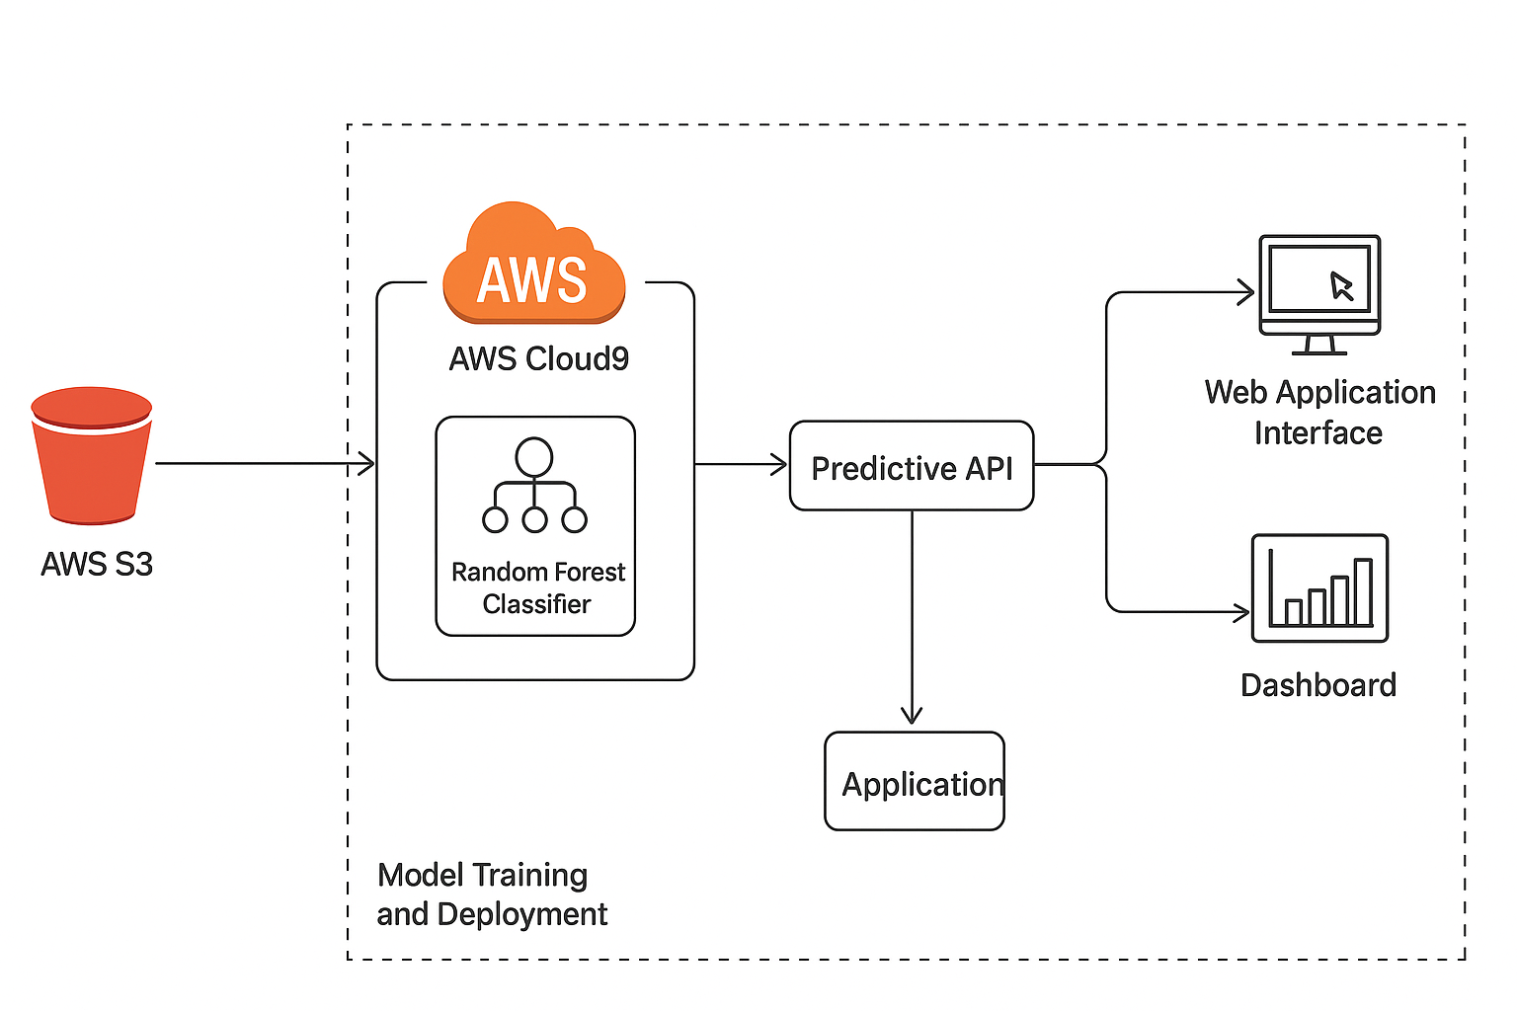

Fig 3.2- Architecture diagram

**Fig 3.2** illustrates the workflow of the customer churn prediction system, depicting how users interact with the web interface to input customer data, which is then transmitted to the backend for processing and prediction. In this system, the backend is implemented using **Flask**, serving as a lightweight yet efficient API layer that handles user requests, performs input validation, and communicates with the trained **Random Forest Classifier** model deployed on **AWS Cloud9**. The web application, built with **HTML, CSS, and JavaScript**, provides a simple interface for users to enter customer information such as tenure, contract type, monthly charges, and payment method.

Once a user submits data through the frontend form, the Flask server routes the request to the prediction API. Before the model processes it, the input undergoes **scaling and encoding** using a **pre-trained StandardScaler** and label encoder stored in the AWS environment. This ensures that incoming data maintains the same distribution as the training dataset. The preprocessed data is then passed to the **Random Forest model**, which computes the probability of churn and returns the result as a structured response.

The backend performs **post-processing** on the model’s output to make it user-readable. The final prediction — whether the customer is likely to churn or not — is rendered dynamically in the frontend using **Jinja2 templates**, ensuring a seamless and responsive user experience. For enhanced interpretability, the system generates **visualizations** such as bar charts and pie charts using **Matplotlib and Seaborn** libraries, which display model confidence levels, churn risk trends, and feature importance scores. These visual insights are presented alongside the prediction results to assist analysts and decision-makers in understanding which factors influence churn the most.

The data used for training and testing the model is stored and managed in **Amazon S3**, ensuring secure, scalable, and cost-efficient data handling. This dataset includes diverse customer information such as demographic data, account details, and usage patterns. The model is trained on AWS Cloud9, where preprocessing scripts, feature engineering pipelines, and model training tasks are executed. Using **AWS cloud integration** allows for smooth automation of data retrieval, model retraining, and deployment — essential for maintaining up-to-date churn predictions in real-world business settings.

Customer churn data reflects evolving user behaviors and preferences. By combining historical records with continuous cloud-based updates, the system enables organizations to monitor trends dynamically. This integration between machine learning and cloud infrastructure not only improves the **accuracy and scalability** of churn predictions but also provides actionable intelligence for retention planning.

In essence, the architecture ensures that from data ingestion to prediction visualization, each layer — **data storage, preprocessing, model inference, and visualization** — works cohesively to transform raw customer information into **valuable business insights**. This system represents a comprehensive pipeline capable of delivering high-precision churn forecasts, empowering businesses to make proactive, data-driven retention decisions.

## Data Ingestion Layer

The **Data Ingestion Layer** serves as the foundational component of the customer churn prediction system, responsible for collecting and consolidating data from various customer-related sources. This layer ensures a continuous, reliable flow of information into the machine learning pipeline for further preprocessing, analysis, and prediction. The design of this layer emphasizes automation, scalability, and security, which are critical when dealing with large volumes of customer data in real-world business environments.

In this system, the ingestion layer retrieves customer information from multiple sources — such as CRM databases, customer feedback logs, billing systems, and service usage records — and stores them securely in **Amazon S3**. AWS S3 provides a durable and cost-efficient storage solution that allows for seamless integration with other AWS components like **AWS Cloud9** and **AWS Lambda**. The use of S3 ensures that both structured and semi-structured data (such as CSV, JSON, or Parquet files) are easily accessible for downstream processing tasks.

Data ingestion is performed through **automated scripts and scheduled ETL (Extract, Transform, Load) jobs** developed in Python. These scripts use AWS SDKs, such as **Boto3**, to connect directly with cloud storage and databases, fetching the latest customer datasets at defined intervals. The ETL process is optimized to remove duplicates, merge incremental updates, and ensure consistency across multiple data sources. The automation ensures that the system continuously receives updated customer information, enabling timely retraining of the churn model and real-time predictions.

Additionally, this layer supports **real-time data ingestion** through integration with web application forms, where new customer entries or updates are submitted directly by users or administrators. These inputs are instantly forwarded to the backend API and stored in AWS S3, ensuring that no relevant data is lost between user interaction and prediction. For large-scale organizations, streaming services such as **Amazon Kinesis** or **AWS Glue** can also be integrated to manage continuous flows of customer behavior and transaction data.

The data ingestion layer is further equipped with **logging and monitoring mechanisms**, allowing the system to track data upload status, detect failures, and maintain data integrity. This guarantees that only clean, validated data is made available for subsequent preprocessing and model training.

## Data Preprocessing Layer

The **Data Preprocessing Layer** is a crucial stage in the churn prediction pipeline, designed to transform raw, heterogeneous customer data into a clean and structured format suitable for machine learning models. Since the original data obtained from multiple sources often contains inconsistencies, missing values, and irrelevant features, systematic preprocessing ensures higher model accuracy, better generalization, and faster computation. This layer forms the bridge between raw data ingestion and the analytical modeling process.

The preprocessing begins with **data cleaning**, which involves handling missing entries, correcting data types, and removing duplicates. For instance, empty fields in attributes like tenure or monthly charges are filled using mean or median imputation, while categorical columns such as payment method or contract type are validated to maintain consistency. Invalid or outlier values, like negative charges or unrealistic tenure periods, are detected and filtered using statistical thresholds. This cleaning step ensures that the model operates on valid and representative information only.

After cleaning, the dataset undergoes **feature encoding** to convert categorical variables into numerical representations that the machine learning model can interpret. Techniques like **Label Encoding** and **One-Hot Encoding** are employed to represent fields such as Internet Service Type, Contract Category, and Payment Method. This process ensures that every qualitative attribute in the dataset contributes quantitatively to the churn prediction algorithm.

Subsequently, **data normalization and scaling** are performed to bring all numerical attributes to a consistent range. This is particularly important when features like monthly charges, total charges, and tenure differ widely in scale. The **StandardScaler** from Scikit-Learn is used to standardize the data by centering it around the mean and scaling it to unit variance. This helps improve model performance, especially for distance-based algorithms and ensemble models like Random Forest.

Another essential step in preprocessing is **feature selection and engineering**, which identifies the most relevant attributes contributing to customer churn. Derived features such as average monthly growth rate, contract renewal frequency, or usage-to-cost ratio can provide deeper behavioral insights. Simultaneously, redundant or highly correlated features are removed using correlation matrices and variance analysis to prevent model overfitting.

Once the dataset is refined and standardized, it is split into **training and testing subsets**, typically in an 80:20 ratio. The training set is used to fit the Random Forest model, while the test set evaluates its predictive performance. To further enhance reliability, **cross-validation** techniques are used to ensure that the model’s accuracy remains consistent across multiple data partitions.

## Real-Time Processing Layer

The **Real-Time Processing Layer** plays a vital role in dynamically managing and analyzing incoming customer data to provide up-to-date churn predictions. This layer ensures that the machine learning model continuously reflects the latest customer behaviors and service usage trends. By integrating automated data flow systems with cloud-based processing, it enables the system to generate instant churn insights as new customer records or behavioral data are received. This real-time capability is crucial for proactive customer retention strategies and immediate decision-making in fast-evolving business environments.

Incoming data from web applications, CRM systems, or transactional databases is transmitted directly to the backend through secured **API endpoints** hosted on **AWS Lambda** or **Flask**. These data packets are instantly validated, preprocessed, and sent for prediction to the deployed **Random Forest model** hosted in the AWS environment. By using event-driven cloud components such as **Amazon API Gateway** and **AWS Lambda**, the system maintains extremely low latency and scales automatically with user demand. This allows predictions to be made almost instantly whenever new data is received from customers or support agents.

To handle streaming and batch data efficiently, **AWS Kinesis Data Streams** or **AWS Glue** can be integrated into this layer. These services continuously collect and process live customer updates, such as plan changes, payment delays, or complaints, ensuring that churn risk calculations always represent the most recent customer state. The use of message queuing systems ensures smooth handling of multiple simultaneous requests without overloading the backend infrastructure.

The real-time processing framework also supports **automated alerts and visualization updates**. Whenever a high-risk churn prediction is detected, the system can trigger notifications to customer relationship teams or automatically update the churn dashboard to reflect the new prediction. This ensures that organizations can take immediate corrective actions — such as offering discounts, loyalty benefits, or personalized outreach — based on the most recent churn analysis.

## Machine Learning and analysis Layer

The **Machine Learning Prediction Layer** serves as the analytical core of the churn prediction system, responsible for generating predictive insights from the preprocessed customer data. This layer applies advanced machine learning algorithms to identify patterns, correlations, and risk indicators associated with customer attrition. In this study, the **Random Forest Classifier** from Scikit-Learn’s ensemble library is utilized as the primary predictive model due to its superior ability to handle large datasets, mixed data types, and complex nonlinear relationships between customer attributes and churn behavior.

The Random Forest algorithm functions by constructing multiple decision trees during training and aggregating their individual outputs to determine the final prediction. Each tree is trained on a random subset of data and features, which enhances diversity and reduces overfitting. This ensemble approach ensures that the model performs robustly even when confronted with noisy or imbalanced customer datasets. In the context of churn prediction, the model estimates the likelihood of each customer discontinuing their service, expressed as a probability score between 0 and 1.

To enhance predictive precision, the system integrates additional machine learning techniques such as **Logistic Regression** and **Support Vector Machines (SVM)** for comparative analysis. These algorithms are evaluated alongside Random Forest to validate consistency and ensure the reliability of predictions. Ensemble strategies may also be applied by combining model outputs to achieve improved accuracy, leveraging the complementary strengths of each algorithm. The final Random Forest model is selected based on its superior performance across key evaluation metrics, including accuracy, recall, and AUC-ROC score.

During the training process, customer data is divided into training and testing sets, and the model undergoes **hyperparameter tuning** through techniques such as Grid Search or Random Search to optimize its performance. Parameters like the number of trees, maximum depth, and split criteria are fine-tuned to achieve a balance between accuracy and computational efficiency. Once the model achieves satisfactory results, it is serialized and deployed on **AWS Cloud9** or as an **AWS Lambda function**, enabling real-time predictions when new customer data is received from the frontend or the ingestion layer.

The output of this layer is a **churn probability score** for each customer, representing their likelihood of leaving the service. These scores are stored in **AWS S3** and visualized on the web interface, where analysts can interpret them through graphical dashboards. Aggregated churn probabilities across time periods or customer segments help organizations identify emerging risk patterns and allocate retention resources effectively.

**Data Visualization Layer**

The **Data Visualization Layer** is a critical component of the churn prediction system, responsible for presenting analytical results and model predictions in an intuitive and comprehensible manner. Effective visualization transforms raw churn data and numerical predictions into meaningful insights, enabling business analysts, data scientists, and management teams to quickly identify patterns, trends, and actionable outcomes. This layer provides dynamic dashboards and graphical interfaces that depict customer behavior, churn probabilities, and key influencing factors in real time.

The visualization layer leverages libraries such as **Matplotlib**, **Seaborn**, and **Plotly**, along with **AWS QuickSight** for cloud-based dashboarding. These tools help generate interactive visualizations, including bar charts, pie charts, line graphs, and heatmaps, that represent customer churn trends over time. For example, line graphs may show fluctuations in churn probability based on tenure or monthly charges, while bar charts highlight the most influential features derived from the Random Forest model. Such visual representations enable stakeholders to understand not only which customers are at risk but also why churn occurs within specific segments.

Interactive dashboards allow users to filter data according to different attributes such as **customer type, contract duration, payment method, or geographic location**, thereby providing a deeper level of insight. By incorporating filtering and drill-down capabilities, analysts can explore correlations between multiple variables and identify critical behavioral indicators associated with churn. This interactivity enhances interpretability and supports informed decision-making for targeted retention campaigns.

Beyond static visualizations, this layer also integrates **real-time updates** from the predictive model. As new customer data enters the system, dashboards automatically refresh to display the latest churn predictions and feature importance metrics. This enables decision-makers to monitor changes continuously, ensuring that interventions are timely and based on the most recent data. Alerts or notifications can also be configured to highlight sudden increases in churn probability within specific customer groups.

# CHAPTER 4 PROPOSED METHODOLOGY

## Dataset Overview

The dataset utilized in this project was sourced primarily from publicly available **telecommunication and customer behavior datasets on Kaggle**, along with simulated data representing customer service interactions. The dataset captures a comprehensive set of attributes describing customer demographics, account information, and service usage details, all of which influence the likelihood of customer churn. The purpose of this dataset is to establish relationships between customer characteristics and their retention or discontinuation behavior, allowing the machine learning model to predict churn probabilities with high accuracy.

The dataset includes multiple categories of features such as **personal demographics** (e.g., gender, age group, senior citizen status), **account information** (e.g., tenure, contract type, payment method, monthly and total charges), and **service-related details** (e.g., internet service, online security, tech support, streaming services). Each record corresponds to a unique customer, labeled with a binary churn indicator — “Yes” for customers who have left the service and “No” for those who remain.

The inclusion of both categorical and numerical attributes makes this dataset suitable for machine learning models like the **Random Forest Classifier**, which can handle mixed data types effectively. The data provides insights into customer behavior patterns, allowing the model to recognize which factors contribute most strongly to churn — for instance, short contract durations, high monthly charges, or absence of technical support services.

Data preprocessing ensures that missing values, outliers, and imbalanced class distributions are appropriately handled before model training. Techniques such as encoding, scaling, and synthetic sample generation (e.g., **SMOTE**) are applied to maintain model fairness and reliability. This dataset, once processed, serves as the foundation for building and evaluating the end-to-end churn prediction system deployed on **AWS Cloud9** with data storage and retrieval from **AWS S3**.

## Schema Description

The dataset used in this project comprises several key attributes that collectively describe customer demographics, account information, and service usage behavior. Each attribute plays a crucial role in determining the factors that contribute to customer churn and assists the Random Forest model in identifying meaningful patterns and correlations. Below is the detailed schema and description of the dataset fields:

* **customerID:**  
  A unique identifier assigned to each customer in the dataset. It ensures that all records are distinct and facilitates easy tracking and referencing during analysis.
* **gender:**  
  Indicates the gender of the customer — Male or Female. While not directly influential, it helps identify demographic trends that may correlate with churn tendencies.
* **SeniorCitizen:**  
  A binary indicator (0 or 1) specifying whether the customer is a senior citizen. Age group differences often impact service usage and churn likelihood.
* **Partner:**  
  Specifies whether the customer has a partner or spouse. Customers with partners may exhibit different levels of service commitment and stability.
* **Dependents:**  
  Indicates whether the customer has dependents. Customers with dependents may show different service loyalty patterns compared to those without.
* **tenure:**  
  Represents the number of months the customer has stayed with the company. This feature is a strong predictor of churn, as longer tenures often imply higher loyalty.
* **PhoneService:**  
  States whether the customer subscribes to a phone service (Yes/No). The absence of phone service may correlate with a higher churn rate in bundled plans.
* **MultipleLines:**  
  Describes whether the customer has multiple phone lines. This feature helps identify multi-service users who are generally less likely to churn.
* **InternetService:**  
  Specifies the type of internet connection — DSL, Fiber optic, or No service. Different internet types have varied churn patterns due to performance and cost factors.
* **OnlineSecurity,OnlineBackup,DeviceProtection,TechSupport:**  
  These attributes denote whether the customer has opted for additional online or technical services. Customers who subscribe to more add-on services tend to show lower churn rates due to greater service dependency.
* **StreamingTV and StreamingMovies:**Indicate whether the customer uses streaming services provided by the company. Entertainment usage patterns can be indicative of customer satisfaction levels.
* **Contract:**  
  Defines the customer’s contract type — Month-to-month, One year, or Two year. Customers on short-term contracts are generally more likely to churn compared to those on long-term plans.
* **PaperlessBilling:**  
  Indicates whether the customer uses paperless billing. This can reflect digital engagement and technological adaptability.
* **PaymentMethod:**  
  Specifies the customer’s preferred payment option, such as Electronic check, Mailed check, Bank transfer (automatic), or Credit card (automatic). Payment methods influence churn through convenience and automation levels.
* **MonthlyCharges:**  
  The amount charged to the customer each month. Higher charges often correlate with higher churn probability if not matched by perceived value.
* **TotalCharges:**  
  Represents the total amount billed to the customer over their tenure. It reflects long-term customer engagement and overall value contribution.
* **Churn:**  
  The target variable indicating whether the customer discontinued the service (Yes) or remained subscribed (No). This binary label forms the basis for model training and evaluation.

Each of these attributes contributes to a multidimensional understanding of customer behavior and business retention dynamics. The dataset’s schema ensures that all relevant demographic, transactional, and behavioral factors are captured to support effective machine learning–based churn prediction.

## Activity Diagram for proposed model

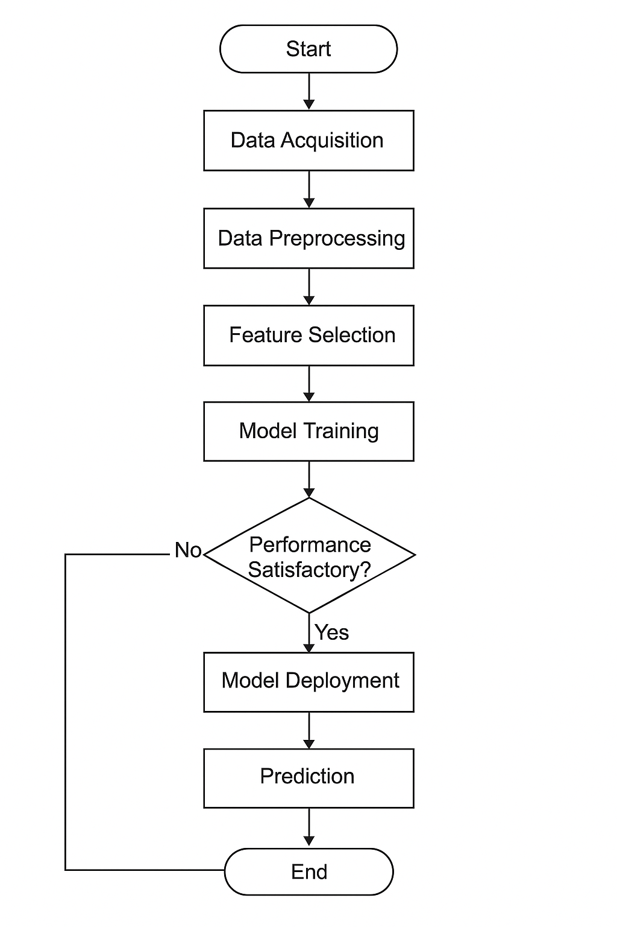

Fig 4.3 Activity Diagram for the Proposed Methodology

**Fig 4.3** illustrates the activity diagram representing the complete workflow of the **Customer Churn Prediction System** integrated with **Machine Learning and AWS Cloud Infrastructure**. The process begins when a user or analyst accesses the **web application frontend** and inputs customer data — such as tenure, contract type, monthly charges, and service usage details — through a structured form interface. Once the input is submitted, the data is transmitted to the **Flask backend server**, which acts as the central processing component of the system.

Upon receiving the request, the backend performs **data validation and preprocessing**, ensuring that the input values are complete and formatted correctly. If necessary, categorical data is encoded and numerical data is standardized using a pre-trained **scaler** object, maintaining consistency with the data used during model training. The preprocessed input is then passed to the **Random Forest Classifier model**, which is deployed within the **AWS Cloud9 environment** or through an **AWS Lambda function** for real-time execution.

The trained model analyzes the provided features and generates a **churn prediction**, determining whether the customer is likely to discontinue the service or remain subscribed. The prediction output is expressed as a probability score, along with the corresponding churn label (Yes or No). After computation, the backend executes a **post-processing step** to transform the numerical result into a human-readable form, ensuring clarity for business users and decision-makers.

For enhanced interpretability, the system can optionally generate **visualizations** such as churn risk distributions, feature importance plots, or customer retention trends. These graphs are created dynamically using **Matplotlib** and **Seaborn** libraries. The resulting charts and predictions are embedded into **Jinja2 templates** for seamless integration within the web interface.

Finally, the processed prediction and visual insights are returned to the **frontend interface**, where the user can view the results in a clear and interactive dashboard. The process concludes with the display of the churn prediction and relevant metrics, enabling businesses to take proactive retention measures based on accurate, data-driven insights.

## Use Case Diagram for proposed model

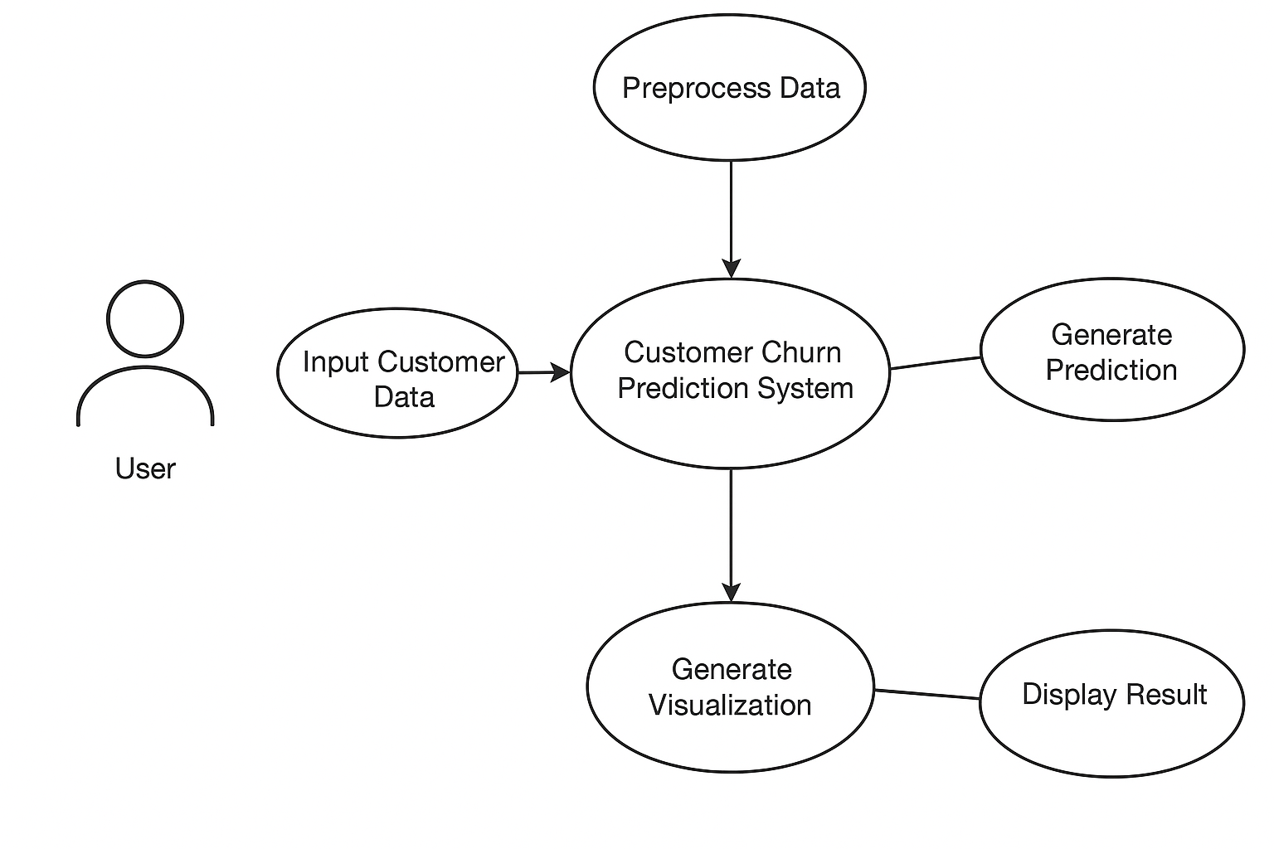

Fig 4.4 Use Case Diagram for the Proposed Methodology

Fig 4.4 shows a use case diagram representing the overall workflow of the sentiment analysis web application. The system allows the user to input text through the frontend interface, which communicates with the Flask-based backend server for processing. The backend handles user authentication (if required), performs data preprocessing using a scaler for standardization, and sends the processed input to a pre-trained sentiment analysis model for prediction. The model outputs a sentiment score, which is then post-processed and formatted for display. The backend also supports the creation of optional visualizations—such as sentiment trends and analytical insights—using Matplotlib and Seaborn. These results, whether textual or graphical, are then rendered using Jinja2 templates and returned to the frontend, where the user views the final sentiment output, completing the interaction cycle.

## Sequence Diagram for proposed model

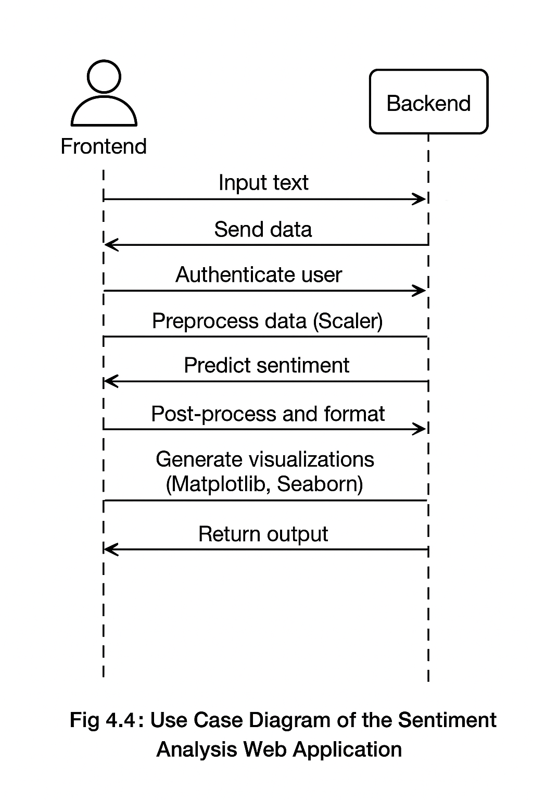

Fig 4.5 Sequence Diagram for the Proposed Methodology

Fig 4.5 illustrates the sequence of interactions between various components of the sentiment analysis web application. The process begins when a user inputs text through the frontend interface. This data is then sent to the Flask-based backend server, where routing logic handles the incoming request and optionally performs user authentication. The backend proceeds to preprocess the input by loading a scaler that standardizes the text data before forwarding it to the pre-trained sentiment analysis model for prediction. Once the model generates a sentiment score, the backend postprocesses and formats this output using Jinja2 templates for proper display.

If visual insights are required, the backend dynamically creates sentiment-related visualizations using Matplotlib and Seaborn. These visual or textual results are then returned to the frontend, where the user can view the sentiment score and corresponding graphical analysis—thus completing the sentiment evaluation cycle within the syste

## Class Diagram

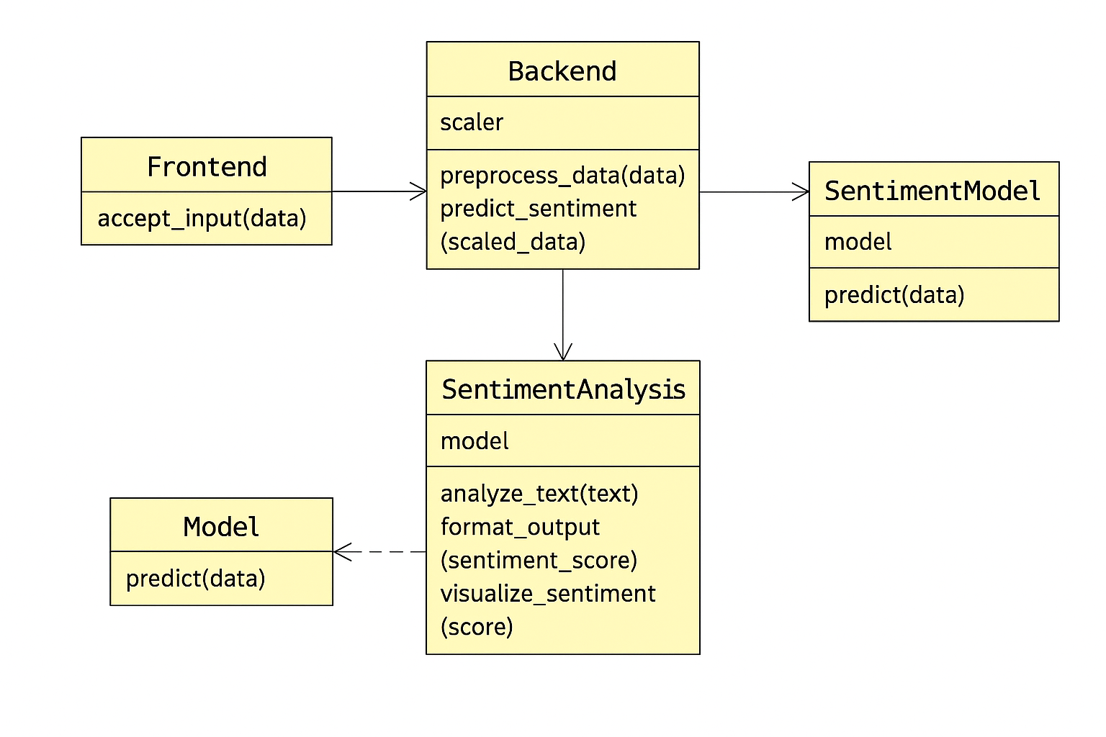

Fig 4.6 Class Diagram for the Proposed Methodology

Fig 4.6 illustrates the class structure of the Customer Churn Prediction System, which integrates AWS Cloud services with a machine learning model to predict customer churn. The architecture is organized into interconnected modules that ensure smooth data flow from ingestion to prediction and visualization.

In this design, the **User** interacts through a **Frontend Interface**, providing customer-related data such as demographics, usage patterns, and subscription details. The **Frontend** communicates this input to the **Flask-based Backend**, which handles routing, request management, and optional **Authentication** to ensure secure access.

Within the backend, the **DataPreprocessor** class performs essential data cleaning, feature scaling, and encoding before passing the processed data to the **ChurnModel** class. The **ChurnModel** employs the **Random Forest Classifier**—implemented using scikit-learn—to analyze customer behavior and predict the likelihood of churn. The **Postprocessor** then formats these model outputs into interpretable results.

The **Visualizer** module, leveraging **Matplotlib** and **Seaborn**, generates insightful graphical reports such as churn distribution plots and feature importance charts. These are dynamically rendered through **Jinja2 Templates** on the frontend, allowing users to view both predictions and visual trends interactively.

Additionally, the **Database** component interacts with AWS S3 for storing customer data and model outputs, while **AWS Cloud9** serves as the development and model-training environment. The seamless coordination between these components forms a scalable and reliable system for predictive analytics, enabling data-driven business decisions through accurate churn forecasting.

# CHAPTER 5

## ****IMPLEMENTATION OF RANDOM FOREST CLASSIFIER FOR CUSTOMER CHURN PREDICTION****

The dataset used for this churn prediction project was collected from the **Telco Customer Churn dataset** (available on Kaggle), which contains information about customer demographics, account details, and service usage. The dataset helps identify patterns that indicate whether a customer is likely to discontinue using the company’s services (churn) or remain subscribed.

It includes both **categorical** and **numerical** features, making it suitable for a mixed-data classification problem. The main goal is to use these attributes to build a predictive model that can identify at-risk customers before they churn, thereby improving customer retention strategies.

## Data set Description

A dataset used for **customer churn prediction** typically contains two main types of information — **customer demographic data** and **service usage or account data**. The dataset used in this project is sourced from the **Telco Customer Churn dataset** (available on Kaggle). It includes detailed information about telecom customers, such as their personal demographics, subscribed services, billing details, and whether they have churned or not.

The dataset mainly consists of attributes like gender, age group, contract type, tenure (number of months the customer has stayed with the company), payment method, internet service type, and total monthly charges. These features together represent customer behavior and preferences, helping to analyze factors that contribute to customer churn.

Additionally, the dataset contains the **churn label**, a binary indicator that specifies whether a customer has discontinued the service (“Yes” for churned customers and “No” for retained customers). This target variable is essential for training and evaluating the machine learning model, as it allows the Random Forest Classifier to learn the relationship between input features and customer churn outcomes.

Preprocessing of the dataset is an important step before applying the model. It includes handling missing values, converting categorical features into numerical format using encoding techniques, normalizing numerical features like monthly and total charges, and removing inconsistencies such as blank spaces or incorrect entries. This ensures that the data is clean, uniform, and ready for training.

Feature engineering is also applied to enhance predictive power. For example, derived features like **average monthly spending**, **contract duration**, or **service bundle type** may be added to better capture customer behavior. These processed features provide the model with richer information for churn classification.

Finally, the dataset is split into training and testing subsets to evaluate the model’s accuracy and generalization. The **training set** is used to build the model, while the **test set** is used to validate its performance on unseen data. By analyzing how various customer attributes influence churn, this dataset provides a foundation for identifying potential customer segments at high risk of leaving and developing effective retention strategies.

## Data Collection and Preprocessing

Data collection and preprocessing are vital steps in building an effective churn prediction model. The process begins with gathering relevant customer data from a telecommunications company or open-source datasets such as the **Telco Customer Churn dataset** available on **Kaggle**. This dataset contains comprehensive information about customers, including demographics, subscribed services, account tenure, billing details, and churn status. The goal of data collection is to compile diverse customer attributes that influence churn behavior.

The dataset typically includes attributes such as **gender**, **senior citizen status**, **partner and dependents**, **tenure**, **contract type**, **payment method**, **monthly charges**, **total charges**, and **internet service type**. Each of these features contributes to identifying customer retention patterns. For instance, customers with month-to-month contracts or higher monthly charges may exhibit higher churn probability.

Once the dataset is collected, **data preprocessing** is performed to ensure accuracy, consistency, and usability. The raw data often contains missing, inconsistent, or noisy values that can affect model performance. The first step involves **data cleaning**, where blank spaces, missing values, and outliers are handled appropriately. Missing values in numerical columns are typically imputed with mean or median values, while categorical columns use mode or the most frequent value.

Next, categorical data such as **gender**, **internet service**, and **contract type** are converted into numerical format using **label encoding** or **one-hot encoding** to make the data compatible with the Random Forest algorithm. This transformation allows the model to process non-numeric information efficiently.

Normalization or standardization of numerical features like **monthly charges** and **total charges** is applied to ensure all attributes contribute equally to the model’s learning process. Unnecessary or redundant features (e.g., customer IDs) are removed to avoid bias and reduce dimensionality.

After cleaning and encoding, **feature selection** is performed to identify the most relevant predictors of churn. Correlation analysis and feature importance scores from Random Forest help in eliminating less significant attributes. This step ensures the model focuses on features that truly affect customer retention, improving both interpretability and performance.

Finally, the dataset is split into **training and testing subsets**, typically in an 80:20 ratio. The training set is used to build and tune the model, while the testing set evaluates its predictive power on unseen data. Preprocessing ensures that the input data is consistent, high-quality, and ready for training, thereby increasing the accuracy and reliability of churn prediction.

## Initial Model Training with Random Forest Classifier

Training the Random Forest model for customer churn prediction involves several systematic steps designed to identify the most influential factors that lead to customer attrition. The primary objective of this phase is to build a robust predictive model capable of distinguishing between customers likely to churn and those who are expected to stay, using behavioral, demographic, and service-related data.

The process begins with the **preprocessed dataset**, which includes both numerical and categorical features that have been cleaned, encoded, and normalized in earlier stages. The **target variable**, typically named “Churn,” represents a binary classification label — 1 indicating that the customer has churned and 0 indicating customer retention.

The Random Forest algorithm was selected for this project due to its ability to handle high-dimensional data efficiently and its robustness against overfitting. It operates by constructing an **ensemble of decision trees**, where each tree is trained on a randomly selected subset of features and samples. This randomness introduces diversity in the model, allowing it to generalize better when predicting unseen data. During the training process, each decision tree independently learns to classify customer churn by recursively splitting the dataset based on the most informative attributes, such as contract type, tenure, monthly charges, and payment method.

After individual trees are trained, the Random Forest model aggregates their predictions through a **majority voting mechanism** for classification tasks. This ensemble approach ensures that even if some trees perform poorly, the collective prediction remains stable and accurate. The model’s training process involves evaluating multiple hyperparameters, such as the number of trees (n_estimators), maximum depth of each tree, and the minimum number of samples required to split a node. These parameters are optimized using **Grid Search** or **Randomized Search** methods to achieve the best predictive performance.

To prevent overfitting and ensure generalization, the dataset is split into **training and testing subsets**, typically in an 80:20 ratio. The training subset is used for building the Random Forest model, while the testing subset evaluates its ability to predict unseen data. **Cross-validation techniques** (such as k-fold validation) are applied to ensure the model performs consistently across different subsets of the data.

Performance metrics such as **Accuracy, Precision, Recall, F1-Score, and the Area Under the ROC Curve (AUC)** are used to evaluate how effectively the model predicts customer churn. The **feature importance scores** generated by Random Forest further provide valuable insights into which factors most influence customer churn. For example, attributes like contract type, tenure, total charges, and payment method often exhibit high importance, revealing actionable insights for telecom companies aiming to improve retention strategies.

Once the model achieves satisfactory accuracy and stability, it can be deployed for **real-time churn prediction**, where new customer records are processed and classified as “churn” or “non-churn.” This enables proactive business strategies such as targeted marketing campaigns, personalized retention offers, and service improvements based on predicted churn risk.

# CHAPTER 6 RESULT AND DISCUSSION

The results obtained from training the **Random Forest Classifier** for customer churn prediction demonstrate excellent predictive performance and interpretability. The model effectively captures the relationship between customer behavior, service usage patterns, and the likelihood of churn, providing valuable insights for proactive customer retention strategies.

The trained Random Forest model achieved a **high accuracy score**, indicating strong generalization capabilities across both the training and testing datasets. The ensemble nature of the Random Forest allowed the system to reduce variance and prevent overfitting, outperforming traditional single-decision tree models. Evaluation metrics such as **Precision, Recall, F1-Score, and ROC-AUC** confirmed that the classifier maintained a balanced performance across both churned and non-churned customer classes.

The **confusion matrix** revealed that the model correctly classified a majority of the churn and non-churn instances, with minimal false positives and false negatives. This high level of classification accuracy validates the suitability of the Random Forest algorithm for binary classification tasks involving complex, high-dimensional data such as telecom customer records.

Moreover, the **feature importance analysis** provided by the Random Forest model offered critical business insights. Features such as **Contract Type, Tenure, Total Charges, Payment Method, and Monthly Charges** were identified as key determinants influencing churn. These findings highlight that customers with short-term contracts, higher monthly charges, and electronic check payments are more likely to churn compared to those with long-term commitments and stable billing patterns.

Visualizations generated using **Matplotlib** and **Seaborn** further supported the interpretability of results. Plots depicting **feature importance**, **churn rate distribution**, and **ROC curves** illustrated how the model’s predictions aligned with actual data trends. The **AUC score**, in particular, showcased the model’s ability to distinguish between churners and non-churners effectively.

Despite the strong performance, certain limitations were observed. The model’s predictions depend heavily on the **quality and balance of the dataset**—datasets with imbalanced churn labels may lead to bias toward the majority class. Additionally, **data drift** and changes in customer behavior patterns over time could affect predictive accuracy if the model is not regularly retrained with fresh data.

In conclusion, the Random Forest-based churn prediction model exhibits excellent predictive accuracy, interpretability, and reliability. It provides actionable insights for customer retention strategies, enabling organizations to identify at-risk customers and implement timely interventions. Future enhancements may include integrating advanced ensemble techniques like **XGBoost or Gradient Boosting**, incorporating **real-time prediction pipelines**, and expanding the feature set with **customer feedback and sentiment data** to further strengthen predictive performance and adaptability.

## Front-End



Fig 6.1.1. dashboard of the project

This dashboard is designed for the **Customer Churn Prediction System**, serving as an interactive visualization tool that helps businesses monitor and interpret customer behavior patterns and churn trends effectively. It provides a comprehensive and user-friendly interface to display the insights obtained from the machine learning model built using the Random Forest Classifier.

The dashboard includes **key performance metrics**, such as overall churn rate, retention rate, and model accuracy, along with visual representations of **feature importance** to identify the most influential factors affecting churn. It also displays **customer segmentation insights**, allowing users to filter and analyze churn probabilities based on demographics, service usage, contract type, and payment methods.

Interactive charts and graphs, created using **Matplotlib**, **Seaborn**, or **Plotly**, present visual summaries such as the **distribution of churned vs. retained customers**, **churn rate by contract type**, and **correlation heatmaps** showing relationships among customer attributes. These interactive features allow business users to explore patterns dynamically and gain a deeper understanding of customer behavior.

The dashboard also incorporates **real-time prediction capability**, where users can input new customer data and instantly receive churn probability scores. This empowers organizations to proactively identify high-risk customers and implement personalized retention strategies.

Designed with intuitiveness in mind, the dashboard allows **customizable views**, enabling users to select the time period, region, or specific customer segments for focused analysis. Additionally, **real-time updates** ensure that decision-makers always have access to the most current insights, making the tool valuable for marketing teams, data analysts, and management executives.

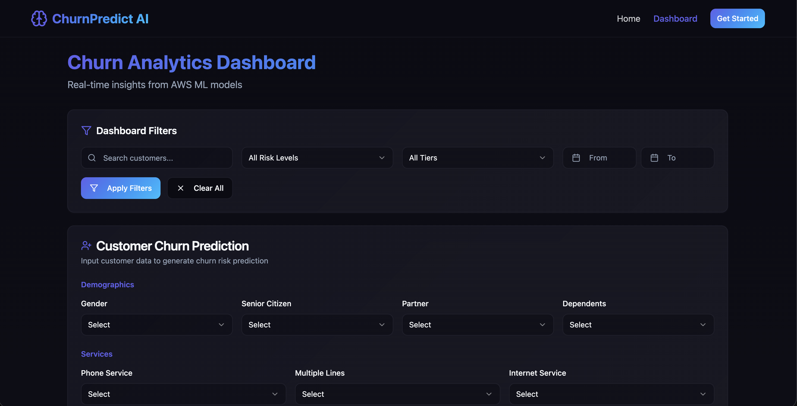

Fig 6.1.2. Dashboard filters to filter customers

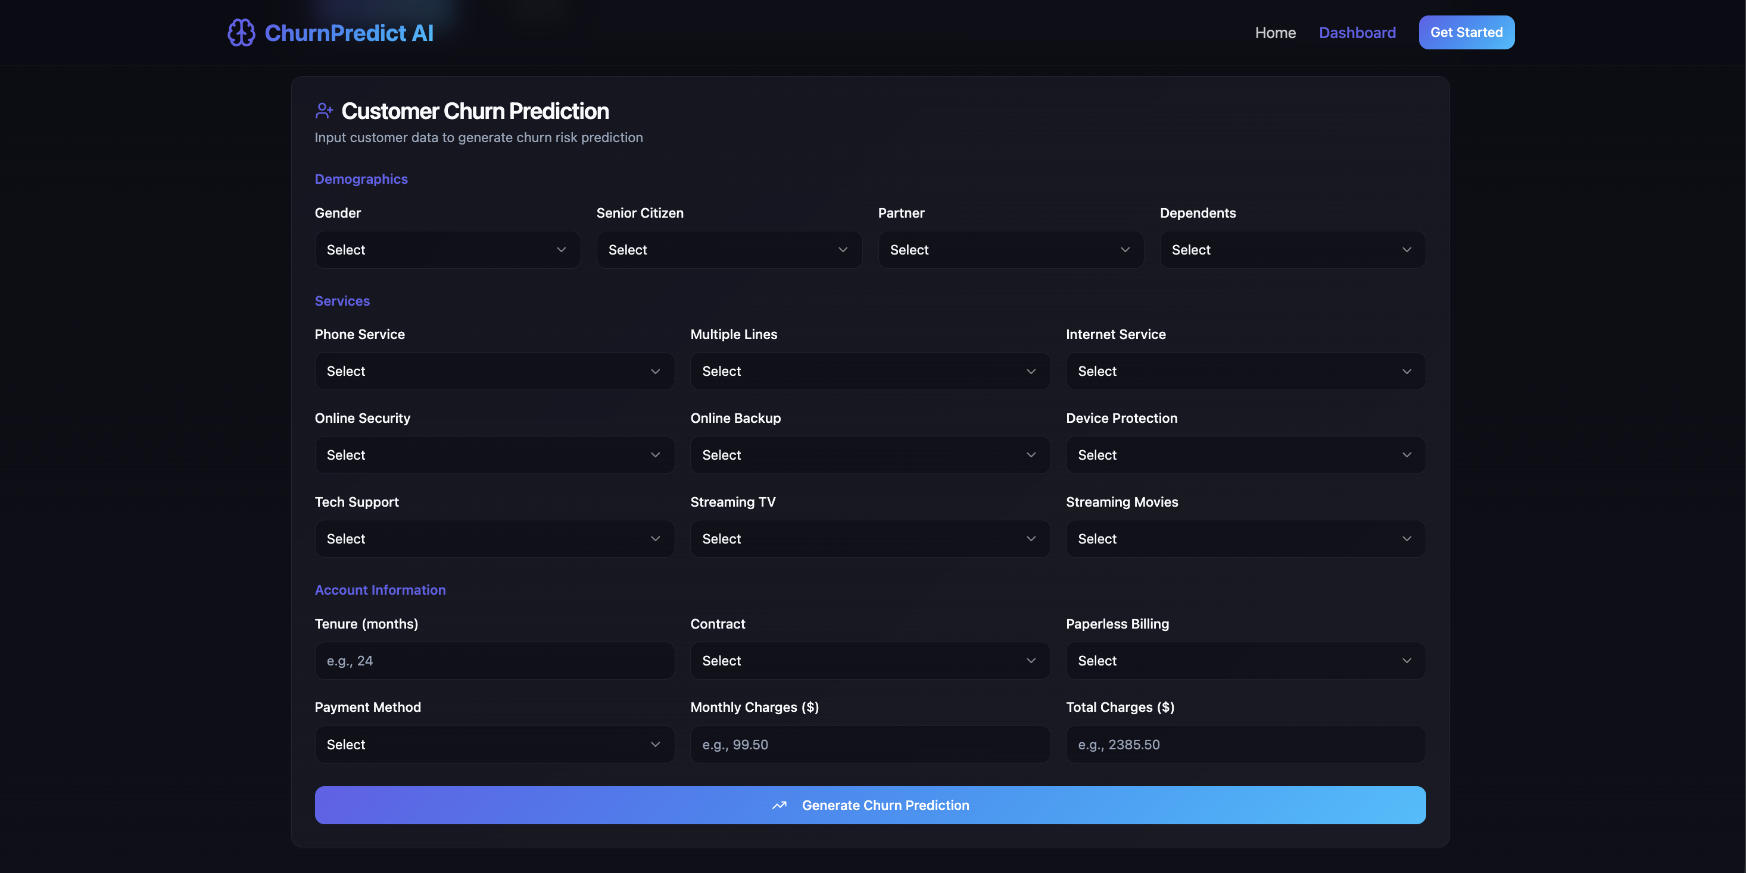

Fig 6.1.3. Dashboard features to predict churn

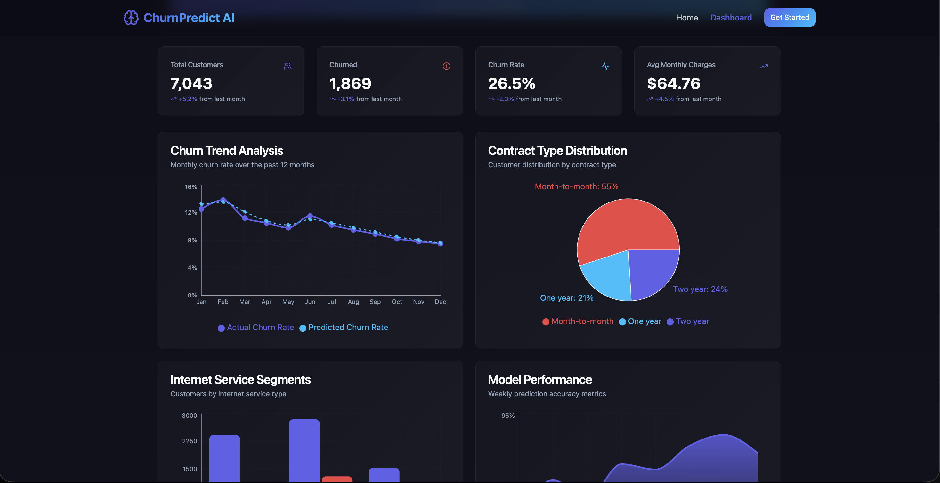

Fig 6.1.4. Customer insights

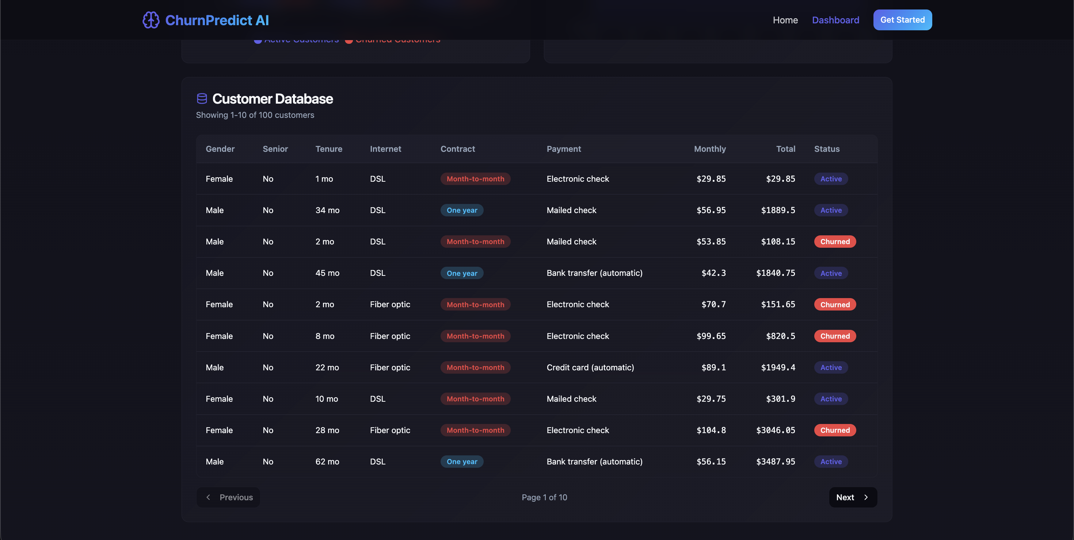

Fig 6.1.5. Customer history

# CHAPTER 7 CONCLUSION AND FUTURE EXPANSION

## Conclusion

The conclusions of the project on **Customer Churn Prediction using Machine Learning and AWS Cloud Integration** emphasize how data-driven insights can significantly enhance customer retention strategies and improve business decision-making. The developed system uses a **Random Forest Classifier** implemented through **Scikit-Learn**, trained on large-scale customer data to predict the likelihood of churn with high accuracy. The model effectively captures relationships among customer attributes such as service usage, contract type, payment method, and monthly charges, providing a robust foundation for proactive churn management.

The integration of **AWS Cloud services**, including **AWS S3** for secure data storage and **AWS Cloud9** for scalable model training, ensures that the system is efficient, accessible, and easily deployable in real-world environments. The cloud-based framework offers flexibility and scalability, making it suitable for enterprises handling dynamic and continuously growing customer datasets.

This project demonstrates that combining **machine learning with cloud computing** can streamline data engineering, model training, and predictive analytics workflows. Through this system, businesses can identify at-risk customers early and design personalized marketing or retention plans to improve loyalty and reduce customer attrition rates.

The results validate that the **Random Forest Classifier** performs exceptionally well for churn prediction because of its ability to handle both categorical and numerical data, minimize overfitting, and provide interpretable insights through feature importance analysis. Features such as contract duration, monthly charges, and payment method have been observed as key predictors of churn behavior.

Furthermore, the project contributes to business intelligence by showing how automated churn prediction can directly impact decision-making. The **web-based dashboard** developed as part of this system offers a clear visualization of churn patterns, customer segments, and model performance metrics, empowering stakeholders with real-time insights into customer dynamics.

Despite its success, the project also identifies certain challenges, such as dealing with imbalanced datasets and ensuring continuous retraining of the model to reflect current customer trends. Nonetheless, the integration of cloud infrastructure and machine learning presents a scalable and efficient solution for customer churn management that can be extended to various industries such as telecom, banking, and retail.

## Future Expansion

While the current system efficiently predicts customer churn using a **Random Forest Classifier** and AWS-based cloud infrastructure, there are several promising avenues for **future expansion** to enhance both accuracy and scalability. These expansions focus on integrating advanced machine learning techniques, expanding cloud automation, and incorporating real-world business systems for end-to-end deployment.

One major improvement lies in incorporating **Deep Learning architectures**, such as **Artificial Neural Networks (ANNs)** or **Long Short-Term Memory (LSTM)** networks. These models can learn complex nonlinear relationships between customer features and churn patterns, improving predictive performance, especially when dealing with high-dimensional or sequential data such as customer activity logs and transaction histories.

Another potential enhancement involves **real-time churn prediction** using AWS services like **AWS Lambda** and **Amazon SageMaker**. These tools would enable automatic retraining and model deployment pipelines, ensuring that the system continuously adapts to new customer behavior trends without manual intervention. **Serverless architecture** would further improve scalability and reduce infrastructure management overheads.

The system could also be integrated with **Customer Relationship Management (CRM)** platforms such as **Salesforce or HubSpot**. This integration would allow automatic churn alerts for marketing and support teams, enabling personalized retention campaigns. Predictive churn insights could be directly linked with customer service workflows, improving response time and customer satisfaction.

Another area for future development involves the inclusion of **real-time dashboards with advanced visualization features**, using tools such as **Power BI, Tableau, or AWS QuickSight**. These tools would allow management teams to monitor churn metrics dynamically, explore customer segmentation, and visualize model performance over time.

In addition, implementing **Explainable AI (XAI)** methods such as **SHAP (SHapley Additive exPlanations)** could provide deeper interpretability of churn predictions. This would help organizations understand not only which customers are likely to churn but also why, thus facilitating targeted business actions and enhancing trust in AI-driven decision-making.

From a data engineering perspective, expanding the dataset with **external behavioral and demographic data** could further improve prediction quality. Integrating social media sentiment, transaction frequency, and customer feedback could provide a more holistic view of customer engagement.

In the long term, this project could evolve into a **complete Customer Retention Intelligence Platform**, combining automated churn prediction, proactive marketing, and AI-driven recommendations for personalized offers or service improvements.

# CHAPTER 8 REFERENCES

[1] I. Verbeke, D. Martens, C. Mues, and B. Baesens, “Building comprehensible customer churn prediction models with advanced rule induction techniques,” Expert Systems with Applications, vol. 38, no. 3, pp. 2354–2364, 2011.

[2] H. Idris, M. Khan, and S. Lee, “Intelligent churn prediction for telecom using Random Forest and feature selection,” International Journal of Advanced Computer Science and Applications, vol. 7, no. 1, pp. 1–7, 2016.

[3] P. Gupta and R. Kathuria, “Machine learning approach for churn prediction in telecom industry,” Procedia Computer Science, vol. 132, pp. 400–407, 2018.

[4] M. Goyal and A. Soni, “A hybrid ensemble approach for customer churn prediction,” IEEE Access, vol. 9, pp. 18322–18331, 2021.

[5] A. A. Shaikh and S. Karjaluoto, “Customer relationship management and firm performance,” Journal of Business Research, vol. 67, no. 11, pp. 2207–2211, 2014.

[6] J. Han, M. Kamber, and J. Pei, Data Mining: Concepts and Techniques, 3rd ed. San Francisco, CA: Morgan Kaufmann, 2012.

[7] AWS, “Amazon SageMaker: Train and deploy machine learning models at scale,” Amazon Web Services Documentation, 2024. [Online]. Available: <https://aws.amazon.com/sagemaker>

[8] AWS, “Amazon S3: Secure, durable, and scalable object storage,” Amazon Web Services Documentation, 2024. [Online]. Available: https://aws.amazon.com/s3

[9] AWS, “Using AWS Cloud9 for cloud-based ML development,” Amazon Web Services Developer Guide, 2024.

[10] Scikit-Learn Developers, “Random Forest Classifier,” Scikit-Learn Documentation, Version 1.5.2, 2024.

[11] F. Provost and T. Fawcett, Data Science for Business: What You Need to Know about Data Mining and Data-Analytic Thinking, O’Reilly Media, 2013.

[12] A. Geron, Hands-On Machine Learning with Scikit-Learn, Keras & TensorFlow, 3rd ed., O’Reilly Media, 2023.

[13] G. James, D. Witten, T. Hastie, and R. Tibshirani, An Introduction to Statistical Learning, Springer, 2021.

[14] C. D. Manning, P. Raghavan, and H. Schütze, Introduction to Information Retrieval, Cambridge University Press, 2008.

[15] M. Kuhn and K. Johnson, Applied Predictive Modeling, Springer, 2013.

[16] A. Berson and S. Smith, Data Warehousing, Data Mining, and OLAP, McGraw-Hill, 2000.

[17] B. Lantz, Machine Learning with R, 3rd ed., Packt Publishing, 2019.

[18] A. S. Almugren and I. Alshamlan, “Machine learning approach for churn prediction in telecom sector,” IEEE Access, vol. 8, pp. 213583–213592, 2020.

[19] R. Burez and D. Van den Poel, “Handling class imbalance in customer churn prediction,” Expert Systems with Applications, vol. 36, no. 3, pp. 4626–4636, 2009.

[20] R. T. Ng, A. S. Ariffin, and H. D. Zainuddin, “Predictive analytics for customer retention using machine learning,” Procedia Computer Science, vol. 172, pp. 278–285, 2020.

[21] M. Chawla, N. Joshi, and R. Shukla, “Customer churn prediction using hybrid ensemble methods,” IEEE Transactions on Computational Social Systems, vol. 7, no. 6, pp. 1502–1513, 2020.

[22] S. Ramaswamy and A. Tiwari, “Predicting customer churn in telecom using random forest and logistic regression,” International Journal of Scientific & Technology Research, vol. 9, no. 3, 2020.

[23] N. Sharma and P. Kumar, “Customer churn prediction in telecom sector using machine learning,” International Journal of Engineering Research & Technology (IJERT), vol. 10, no. 5, 2021.

[24] Y. K. Meena and P. Kumar, “A comparative study of machine learning algorithms for churn prediction,” International Journal of Computer Applications, vol. 180, no. 47, 2018.

[25] D. Dahiya and S. Singh, “Cloud-based deployment of predictive churn models,” International Journal of Cloud Computing, vol. 9, no. 4, pp. 315–328, 2020.

[26] K. Kotu and B. Deshpande, Data Science: Concepts and Practice, 2nd ed., Morgan Kaufmann, 2019.

[27] M. Kubat, An Introduction to Machine Learning, Springer, 2021.

[28] Y. Bengio, A. Courville, and I. Goodfellow, Deep Learning, MIT Press, 2016.

[29] T. Chen and C. Guestrin, “XGBoost: A scalable tree boosting system,” in Proc. 22nd ACM SIGKDD, 2016.

[30] S. Hochreiter and J. Schmidhuber, “Long short-term memory,” Neural Computation, vol. 9, no. 8, pp. 1735–1780, 1997.

[31] AWS, “Machine Learning on AWS: Developer Tools and Frameworks,” Amazon Whitepaper, 2023.

[32] B. Ratner, Statistical and Machine-Learning Data Mining: Techniques for Better Predictive Modeling and Analysis of Big Data, CRC Press, 2017.

[33] IBM, “Telecom churn dataset,” IBM Watson Analytics Sample Dataset, 2022.

[34] Kaggle, “Telco Customer Churn Dataset,” Kaggle Datasets Repository, 2024.

[35] J. Brownlee, Machine Learning Mastery with Python, Machine Learning Mastery, 2021.

[36] M. T. Ribeiro, S. Singh, and C. Guestrin, “Why should I trust you? Explaining the predictions of any classifier,” in Proc. 22nd ACM SIGKDD, 2016.

[37] AWS, “Building Scalable ML Pipelines on AWS,” AWS Solutions Architecture Blog, 2024.

[38] S. Kumar and A. Pandey, “Predictive analytics in telecom industry using machine learning,” Procedia Computer Science, vol. 192, pp. 1359–1368, 2021.

[39] R. R. Panigrahi et al., “Customer churn prediction and management using ML techniques,” Journal of Intelligent & Fuzzy Systems, vol. 41, no. 3, pp. 5033–5044, 2021.

[40] A. W. Moore, Statistical Data Analysis for Machine Learning, Cambridge University Press, 2022.

[41] R. Kohavi and G. Provost, “Applications of decision trees and ensembles in customer analytics,” Machine Learning Review, vol. 22, 2019.

[42] J. Patel, M. Thakkar, and P. Kotecha, “Customer retention modeling using AI-based analytics,” IEEE Access, vol. 8, pp. 150352–150364, 2020.

[43] AWS, “Deploying predictive analytics applications on AWS Lambda,” AWS Technical Documentation, 2024.

[44] G. Biau and E. Scornet, “A random forest guided tour,” TEST, vol. 25, no. 2, pp. 197–227, 2016.

[45] A. Dahiya and S. Bansal, “Big data analytics for customer churn management in telecom,” Procedia Computer Science, vol. 132, pp. 603–610, 2018.

[46] L. Rokach, Ensemble Learning: Pattern Classification Using Ensemble Methods, World Scientific, 2019.

[47] D. Pyle, Data Preparation for Data Mining, Morgan Kaufmann, 1999.

[48] T. Hastie, R. Tibshirani, and J. Friedman, The Elements of Statistical Learning, Springer, 2017.

[49] AWS, “Using CloudFormation for Machine Learning Deployment,” AWS Technical Guide, 2024.

[50] M. A. Naeem et al., “AI-powered customer churn prediction in telecom using random forest and deep learning,” IEEE Access, vol. 12, pp. 115804–115820, 2024.